IRAQ: Unfinished and Abandoned Buildings - Technical Guidance ^{[1]} - v12

INTRODUCTION
This Technical Guidance Note has been developed by Shelter Cluster Iraq’s Technical Working Group on Unfinished and Abandoned Buildings. It provides guidance to agencies on appropriate processes for improving buildings that shelter displaced and conflict-affected families, both internally displaced populations and refugees, and the considerations that need to be taken into account during implementation of such works. The document is based upon the Inter-Agency Shelter Sector Coordination Working Group, Guidelines on the Rehabilitation of Sub-Standard Buildings (Lebanon, August 2015), as well as lessons learned from responses involving unfinished and abandoned buildings by Shelter & NFI Cluster partners in Iraq, guidance offered in similar contexts, and global guidelines and standards on shelter programming and NFI distribution.

The needs faced by displaced and vulnerable households living in inadequate shelter conditions may be addressed in several ways. Two of the approaches currently used in Iraq are 1) Rehabilitation / Durable Upgrades and/or 2) Sealing-Off Kits (SOK) to ensure shelters offer protection from the weather as well as security, privacy and dignity.

These shelter options aim to address the sub-standard physical conditions encountered in many unfinished or abandoned buildings, and may be implemented through a number of different modalities, such as in-kind kits, vouchers, cash, provision of labour support, hiring of contractors, or local labour teams, with varying degrees of participation from owners, occupants and communities. A coordinated approach to the provision of shelter and NFI or household item assistance is strongly recommended.

INTEGRATED SHELTER-WASH
Requirements for shelter upgrading or rehabilitation may be situated within a range of shelter and settlement typologies, from areas of transit to formal camps, spontaneous sites, collective centres, hosted and rented accommodation, and return locations. Criteria assessing the adequacy of shelter goes beyond “covered living space” and includes sufficient and appropriate access to services and infrastructure, such as water and sanitation. Shelter interventions in Unfinished and Abandoned Buildings therefore include improvements to these key services and utilities at the building, household or shelter level. At settlement-level, this responsibility is undertaken by duty bearers with the support of the CCCM and WASH Clusters.

See Annex 7 for more information on the Integrated CCCM-HLP-Shelter-WASH Approach developed by ECHO partners in Iraq.

SUMMARY OF SHELTER IMPROVEMENT PROCESS

Assessment data e.g:– CCCM RASP
Intervention options and priorities
- ESTABLISH OCCUPANT VULNERABILITY, STATUS AND NEEDS
TOOL A:
PRIORITISATION TOOL

Government approvals
Ownership documentation
- ESTABLISH BUILDING AND OWNERSHIP STATUS
TOOL B:
INTERVENTION THRESHOLD MATRIX

REHAB / DURABLE UPGRADE?
SEALING OFF KIT?
TYPE OF INTERVENTION

3. TECHNICAL ASSESSMENT
Cost Analysis
Outline design
Go/No Go decision
TOOL C:
HARMONISED SCOPE OF WORKS

4. TECHNICAL DESIGN
BOQ and Scope of Works
Drawings

VARIOUS TECHNICAL GUIDANCE

Negotiations to enable security of tenure captured in Agreements between agency, owner and occupant
5. PERMISSIONS AND AGREEMENTS (Annex 4)

Procurement; contracting
Technical supervision
Technical acceptance
Handover
6. IMPLEMENTATION (Annex 5)

7. POST-COMPLETION (Annex 6)
Satisfaction surveys
Post-Distribution Monitoring
Focus Group Discussions
Key Informant Interviews
Reporting to Cluster

1. ESTABLISH OCCUPANT STATUS AND NEEDS
An occupant socio-economic survey should be undertaken to determine the vulnerability and scope of technical needs of assistance of families at each location, to determine the general type and priority of interventions that are necessary. This will involve an assessment of the Shelter Adequacy in relation to meeting minimum standards and addressing the basic needs of occupants. The outcome of this survey should provide an a) Outline of necessary range of necessary and/or possible interventions; b) An appreciation /range (not too detailed) of the cost of interventions. A Prioritisation Tool (Tool A) has been developed by ECHO partners in Iraq to assist in these assessments.

The tenure status of the occupants should also be determined. Rental or tenure agreements between occupants and owner should document, in a transparent and understandable manner, the duration of the agreement, the amount of rent and utilities to be paid, and the rights and obligations of both parties. However, in many cases no legal documentation exists, and tenancy may have been agreed verbally. In these cases, the implementing agency should negotiate security of tenure for the occupant through the agreements signed between parties (see Section 4). The terms and conditions of occupancy should also be clarified, particularly with regard to the scope of modifications that are feasible (for example, in the use of Sealing Off Kits).

ANNEX 1

Guide to Annexes
This document is the first part of guidance produced to address shelter assistance in Unfinished and Abandoned Buildings, and focuses on the considerations and necessary steps involved in effective programme management. Stages in the process, as summarised above, are explained in more detail in the following pages, with links to Annexes containing examples of tools, documents and templates that can be used to inform project implementation. These documents are for reference purposes only thanks to the support of the author agencies.

2. ESTABLISH BUILDING AND OWNERSHIP STATUS
2A. BUILDING STATUS
Prior to commencing interventions, a number of pre-requisites need to be in place in order to ensure the legality of shelter improvement support in a particular building or site. Confirmation that the building conforms to governmental planning and building regulations is required, as well as that potential interventions meet local legislative requirements, conditions or constraints and have official approval from the authorities. In some cases, at the physical level, the condition of the building may be so sub-standard that it would pose more risk to residents to promote their continued occupancy (for example, in buildings where the structural integrity has been so severely compromised as to present a serious danger), and so it would be better to facilitate a discussion on relocation. This also has budgetary implications, whereby the excessive cost of rehabilitating a building in such poor condition is hard to justify against the number of potential beneficiaries if the greatest needs are to be met.

2B. OWNERSHIP STATUS
Ownership of the building must be determined before agreements on occupancy and rehabilitation can be made in order to best protect the rights of displaced populations to attain durable shelter, as well as to protect the rights of owners and landlords, and reduce likelihood of conflict or tension in the community which may negatively impact displaced families. More detailed information on this is contained within the Intervention Threshold Matrix.

An Intervention Threshold Matrix (Tool B) has been developed by ECHO partners to assist in deciding whether a) Rehabilitation/Durable Upgrading or b) Sealing Off Kits would be most appropriate for the specific location being assessed. In some cases, a policy of advocacy may be the most appropriate, with no or minimal shelter assistance. Other forms of assistance may also be deemed appropriate.

During the process of identifying and confirming Building and Ownership Status, ongoing consultation and involvement of affected families, target groups and key stakeholders (particularly local authorities, community representatives and building/land owners) is necessary in order to come to agreement on whether works will be acceptable to all parties, and the acceptable extent of those works. This should be a participatory process of engagement that enables decisions on assistance to be made rapidly, informing the next stages in the process, but is also an important opportunity to advocate and negotiate for the rights of displaced and conflict-affected persons to achieve durable shelter. Technical Design should only proceed once it is clear that Agreements will be accepted and signed.

ANNEX 2

3. TECHNICAL DESIGN
Once general needs and pre-requisites are clarified and confirmed, a technical building survey by a qualified engineer is needed to determine the exact scope of works required to make the building safe and adequate. This builds on the information collected through preliminary assessments of intervention priorities and occupants’ shelter needs, to enable a detailed plan for shelter assistance to be developed. This will lead to detailed design, drawings, Bills of Quantities (BOQs) and other planning and monitoring tools (e.g. Scope of Works, Schedule of Works) necessary for the implementation of works to agreed designs, quality, specifications and timeframe.

The design of interventions and specification of materials should conform to Iraqi National Building Codes, as well as to local regulations. Where deviations occur, for example due to lack of market availability, alternatives should be approved by the relevant local government department. Design should include consideration of connecting to services and utilities, as well as the ability of beneficiary families, owners or local authorities to operate, maintain and repair the works undertaken (including the bearing of costs).
Adequacy includes consideration of:
- Adequate privacy
- Adequate space
- Physical accessibility
- Adequate security
- Security of tenure
- Structural stability and durability
- Adequate lighting
- Protection against the elements
- Heating and ventilation
- Adequate basic infrastructure, such as water supply, sanitation and waste-management facilities
- Suitable environmental quality and health-related factors
- Adequate and accessible location with regard to work and basic facilities
- Affordable cost

Safety includes consideration of:
- Natural hazards (e.g. high winds, floods, health)
- Localised risks (e.g. fire, pollution)
- Other risks (e.g. ERW, areas of conflict)
- Risk and hazard prevention, preparedness, mitigation, and response (e.g. fire, falling/trip hazards, injury, electrocution)
- Siting and location of shelter
- Structural integrity
- Layout and detailed design
- Construction quality
- Quality of materials
- Access and accessibility
- Operation, maintenance and repair

A Harmonised Scope of Works (Tool C) has been developed by ECHO partners in Iraq to support the standardisation of specifications and interventions, in order to ensure equity of assistance between beneficiary households, consistency of implementation approaches and technical standards between agencies.

ANNEX 3

4. PERMISSIONS AND AGREEMENTS

PERMISSION FOR WORKS TO BE UNDERTAKEN
When working in a new area, it is customary to approach the local authorities to inform them of the activities and the contact points for the NGO. Formal approval for working on UABs is generally not requested, a ‘facilitation’ letter or broader MoU may prove useful but is very dependent on the NGOs.

The only exception to this would be if the local authority own the building. In such cases, they would be treated as the ‘owner’ and so would be party to the MoU.

AGREEMENT OF INVOLVED PARTIES TO WORKS
Where the distribution of kits consists of items which could lead to invasive repairs or upgrades to buildings (e.g. sealing-off kits, tenant-driven upgrades), beneficiaries should be assisted to obtain formal permission from building owners before installation of such items. Otherwise there is a risk that beneficiaries will inadvertently breach the terms of their verbal or written lease agreement, wherein repairs or upgrades by the tenant without permission from the building owner are often not permitted, thereby putting themselves at risk of eviction.

Considerations may include:
- Negotiate for utilities to be included in the rental agreement, or ensure agreements capture the amount and frequency of utility bills to be paid.
- Rehabilitation can be conducted in exchange for a period of free rent or reduced rent that is at least equivalent in value to the rehabilitation works. This is in order to give the beneficiary household a benefit equal to or greater than the cost of the works, and other associated payments made by the implementing agency to the building owner.
- The rent-free or rent-reduction period should begin once the rehabilitation has been completed. For example, beneficiaries in occupied units should benefit from the hosting period once the work has been completed and the housing unit brought up to minimum standards.
- Rehabilitation should provide at least 12 months of secure tenure for beneficiary households by providing a written occupancy agreement(s) with all parties.
- Agencies implementing rehabilitation are required to conduct minimum monitoring visits during the rent-free or rent-reduction period in order to ensure that the physical works are completed as agreed and that the property owner adheres to the agreed minimum period of tenure and period of reduced/free rent.

Some suggested minimum requirements for beneficiary-owner-agency agreements:
- Specify the duration of the agreement and the rent to be paid, if any.
- Specify that if the occupant leaves, landlord and/or occupant must inform the agency and allow the agency to choose another beneficiary household or accept a replacement tenant who meets the agency’s vulnerability criteria.
- Specify the type, amount, and frequency of utilities to be paid.
- Occupant should not tamper with or remove the installations.
- Both parties should respect each other’s privacy, maintain the property and surroundings and maintain a peaceful environment.
- Owner is to maintain connections to water, electricity and sewage uninterrupted and charge only for the proportional use of these services.
- Clause on non-eviction, and the conditions required to make a lawful eviction.

ANNEX 4

5. IMPLEMENTATION
Implementation of shelter assistance in the context of Unfinished and Abandoned Buildings (such as Rehabilitation/Durable Upgrading or Sealing Off) may occur through a number of different modalities. Some of the main benefits and drawbacks of various approaches are suggested below, although these will be highly context-specific and should be evaluated more closely as part of the Technical Design phase alongside agency capacity and experience; budget and time availability; capacities, vulnerabilities and interests of owners and affected households; local authority requirements, and other factors. Other approaches – or combinations of approaches – may also be possible.

 | MODALITY | BRIEF DESCRIPTION | + | -
IN-KIND ASSISTANCE | Agency implementation  Contractor | Implementing agency tenders and contracts a professional contractor to undertake works | Generally faster construction times.  Quality assurance.  Reduced unit prices for materials through bulk/wholesale purchasing.  Useful for high value projects, standardised, or large-scale works (procurement thresholds). | May not accept small works or variations to best meet beneficiary needs.  May not engage with local community or benefit local economy.  Other commitments may have knock-on delays.
 | Agency implementation  Local labour | Implementing agency recruits local labourers or labour teams to undertake the works | Supports local economy and employment (host, displaced).  May contribute towards social cohesion.  Builds skills amongst recruits.  Greater likelihood of acceptance by local community.  Interventions attuned to needs.  Simultaneous construction across multiple sites. | Recruitment and training of labourers, labour teams and team-building is time-consuming and requires significant prior planning.  Complex management required of materials, tools and labour.  High resources needed for supervision.  Higher likelihood of slow progress or lower quality.
 | Owner-driven | Assistance is provided to the building or land owner in order to undertake works | Provides an incentive towards security of tenure for occupant displaced families.  Opportunity for assuring quality. | Close technical support and supervision required to ensure quality and timeliness.  Improvement in building standard may prompt an increase in rent or risk of eviction.
 | Tenant-driven | Assistance is provided to the tenant/occupant in order to undertake works | Interventions meet needs more effectively.  Empowerment of affected families.  Skills building opportunity. | Quality control issues.  Requires high technical supervision and resources.  Risk of diversion of assistance to meet other, more pressing needs.  Requires close negotiations and monitoring with owners.
CASH-BASED | Vouchers | Materials/tools in order to undertake the works are purchased on the local market through redeeming vouchers at shops. | Supports local economy and may indirectly contribute towards social cohesion.  Control over quality / specifications. | Access to markets is required.  Wide and consistent availability of items on local markets is necessary.  High resources needed for subsequent implementation to time/quality.
 | Cash | Cash is provided to allow beneficiaries to purchase materials / tools and/or hire labourers in order to undertake the works. | Allows beneficiaries to contribute to self-assistance with dignity.  Benefits local economy.  May result in more rapid delivery and greater quality, meeting needs in most appropriate ways. | May increase vulnerabilities/ conflicts in or between households (including with host community).  May not be used to effectively meet shelter needs if other needs are more pressing.  High resources needed in terms of management and supervision.

Technical inspections are normally made by agencies on the basis of Scopes of Work and Bills of Quantity. The involvement of local authorities and key stakeholders (beneficiaries, owners) in monitoring progress is advised.

Once works have been completed, there may be a Warranty Period during which time defects should be corrected, and Technical Acceptance by the implementing agency (and local authorities if relevant). Handover to owner and/or occupants should be undertaken, as clarified through the signed Agreements.

ANNEX 5

6. POST-COMPLETION
In order to evaluate whether assistance has been effective in improving the safety and adequacy of shelter, Satisfaction Surveys should be undertaken after completion with project beneficiaries. Post-Distribution Monitoring (PDM) may also be required if items, kits, cash or vouchers have been distributed to beneficiaries. Other means of monitoring and evaluating the impact of the interventions may be through: post-completion technical surveys, focus group discussions with communities (host, beneficiary), key informant interviews with other stakeholders (including land/building owners and local authorities).

Monitoring visits to verify the upholding of agreements signed as part of the shelter intervention should take place regularly during the contract period between owner and occupant. The suggested frequency is a) within the first month, b) twice during the hosting period, and c) one to two months before the agreement expires.

Agencies implementing rehabilitation have a responsibility to monitor the following aspects:
- The reduced/free-rent period is honoured
- Any disputes are identified and resolved
- Occupancy rates are captured
- Beneficiary intentions for after the reduced/rent-free period are captured
- Special needs of the families beyond the scope of the shelter assistance are referred to other agencies and service provided as possible.

Regular monitoring of the ongoing safety and adequacy of the improved shelter is usually required. This may require the support of CCCM partners to flag areas of concern and engage communities or agencies in maintenance. For more information on Integrated Approaches between CCCM, HLP, Shelter and WASH, see Annex 7.

ANNEX 6

REPORTING
Geo-localisation in which shelter interventions have been undertaken should be shared with the cluster, allowing for better coordination and information sharing. Activities should also be reported under the Shelter Cluster and, where relevant, under WASH, through ActivityInfo.

Other information would be helpful to share with the cluster includes:
- Number of families per shelter (and average area (m2) per person) and WASH facilities available
- Intention of families assessed (intended duration of stay in assessed location)
- Rental costs and other household expenditure (e.g. utilities)
- Existing agreements between occupants and owners
- Types of ownership documentation existing
- Existing shelter and settlement typology; construction form
- Extent of damage (e.g. None, Minor, Moderate, Severe)
- Selection criteria / vulnerability scoring criteria used
- Types of agreements / permissions collected during implementation
- Modality of implementation; uses of assistance (intended, actual)
- Materials/items, quantities and specifications provided through assistance
- Beneficiary satisfaction with assistance (normative/perception – e.g. privacy, dignity, security, safety, protection from climate)
- Opinions / satisfaction of owners
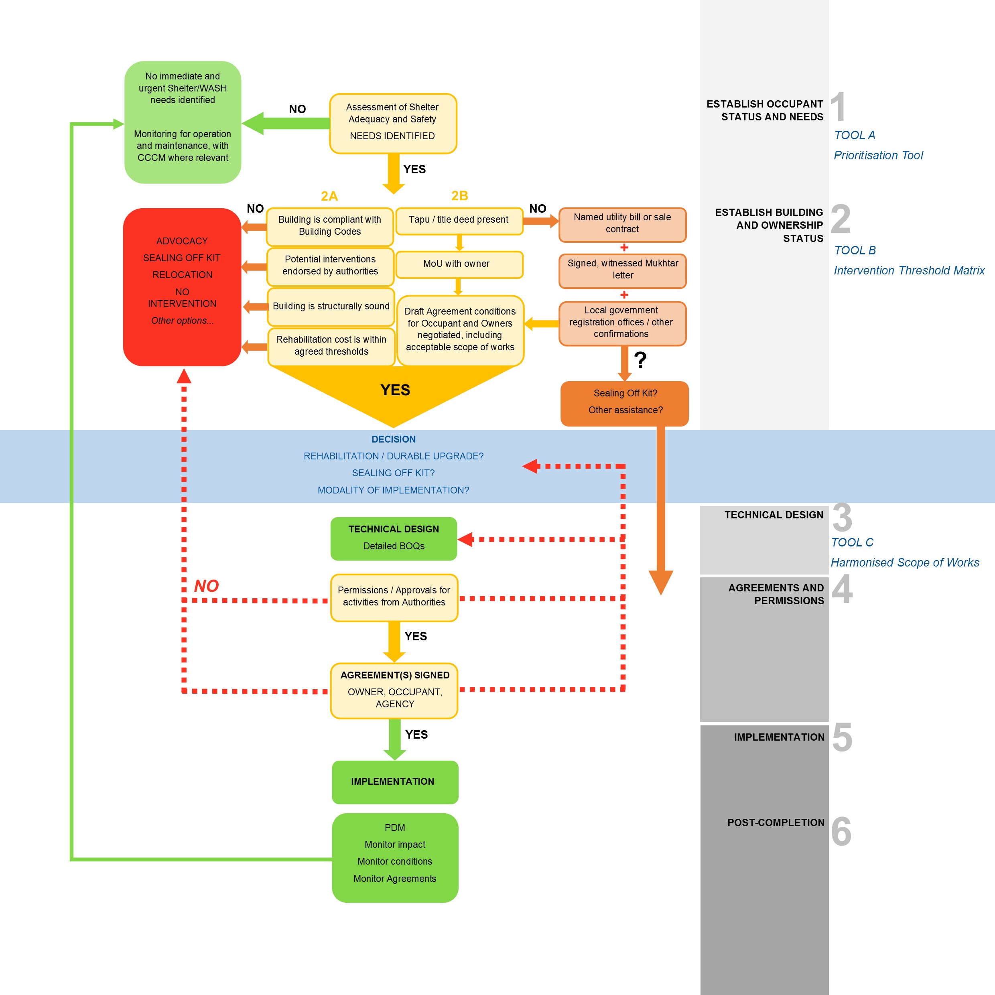

ANNEXES

Back to start

The following Annexes contain examples of documents that have been used in shelter improvement interventions in Unfinished and Abandoned Buildings in Iraq since 2014, as well as links to sources and further reading.

Annex 1 OCCUPANT STATUS AND NEEDS
Shelter Cluster Iraq - Guidance Note: Defining Shelter Adequacy
NRC Urban Accessibility Assessment
Guidance on Including Older People in Emergency Shelter Programmes, IFRC and Help Age International, 2011, http://www.ifrc.org/PageFiles/95749/HelpAge-IFRC-Shelter-Guidelines.pdf

All Under One Roof: Disability-inclusive shelters and settlements in emergencies, IFRC in partnership with Handicap International and CBM, 2015, http://www.cbm.org/article/downloads/54741/All_Under_One_Roof_-_Disability-inclusive_shelter_and_settlements_in_emergencies.pdf

Annex 2 BUILDING AND OWNERSHIP STATUS
Tool B: Intervention Threshold Matrix (example tool developed by ECHO partners)
NRC Checklist of the Right of Use Contract and Rent-Controlled Lease Agreement
Example of letter from Mukhtar attesting to ownership with witness signatures
General Power of Attorney

Special Power of Attorney

Security of Tenure in Humanitarian Shelter Operations, NRC and IFRC, 2013, http://www.ifrc.org/Global/Documents/Secretariat/201406/NRC%20IFRC%20Security%20of%20Tenure.pdf

Securing Tenure in Shelter Operations, NRC, 2016 https://www.sheltercluster.org/sites/default/files/docs/nrc_shelter_tenure_guidance_external.pdf

Handbook on Best Practices, Security of Tenure and Access to Land – Implementation of the Habitat Agenda, UN-Habitat, 2003, http://unhabitat.org/books/handbook-on-best-practices-security-of-tenure-and-access-to-land-implementation-of-the-habitat-agenda/

Annex 3 TECHNICAL DESIGN
Tool C: Harmonised Scope of Works (example tool developed by ECHO partners)
NRC Privacy, Safety and Security Assessment
NRC-UNHCR Example BOQ

Annex 4 PERMISSIONS AND AGREEMENTS
NRC Right of Use Contract

NRC Declaration of Understanding
NRC Rent-Controlled Lease Agreement

NRC Agreement for Informal Collective Centre Rehabilitation (Contractor)
NRC Agreement for Informal Collective Centre Rehabilitation (Owner-driven)

NRC “Cooperation Agreement” between agency and IDP Representative

UN-Habitat Rehabilitation Agreement between Lessor and Local Authority
UN-Habitat Rehabilitation Agreement Written Testimony between Lessor and Lessee
UNHCR Agreement on Sealing Off Kits
For more information on Housing, Land and Property (HLP), please see the Resources section of the Global Shelter Cluster website, https://www.sheltercluster.org/library/housing-land-and-property

Annex 5 IMPLEMENTATION
Literature Review of Cash in Shelter, Dewast, C., Global Shelter Cluster, https://www.sheltercluster.org/sites/default/files/docs/literature_review_of_cash_in_shelter.pdf

Global Shelter Cluster Position Paper on Cash and Markets in the Shelter Sector https://www.sheltercluster.org/sites/default/files/docs/gsc_position_paper_cash_and_markets_in_the_shelter_sector_-_final.docx

For more information on the use of cash-based modalities in Shelter programming, please see the Resources section of the Global Shelter Cluster website, https://www.sheltercluster.org/library/shelter-and-cash

Annex 6 POST-COMPLETION
NRC Final Report FGD with Property Owners
ACTED AMEU Evaluation Report for Sealing Off Kits

Annex 7 INTEGRATED APPROACHES
Flowchart on Integrated CCCM, HLP, Shelter and WASH approaches developed by ECHO partners in Iraq, 2016
Flowchart – detailed of integrated Shelter-WASH approach developed by ECHO partners in Iraq, 2016
CCCM Information Management Flowchart, 2016
Lessons Learned from ECHO Integrated CCCM-Shelter-WASH Approach
Water, Sanitation and Hygiene: Meeting the Challenge of Rapidly Increasing Challenges in WASH, DG ECHO Thematic Policy Document No. 2, May 2014, https://ec.europa.eu/echo/files/policies/sectoral/WASH_policy_doc_en.pdf

Shelter and Settlements Guidelines, DG ECHO (to be published later in 2016)

Camp Management Toolkit 2015, Global CCCM Cluster, http://www.globalcccmcluster.org/tools-and-guidance/publications/camp-management-toolkit-2015

Global WASH Cluster Resources, http://washcluster.net/tools-and-resources/

ACKNOWLEDGMENTS
The Global Shelter Cluster is supported by the European Commission’s Humanitarian Aid and Civil Protection department (ECHO).
Shelter Cluster Iraq would like to acknowledge the significant contribution made by agencies and individuals who have provided input to the development of this document, particularly ECHO’s partners in Iraq – DRC, IOM and NRC.

http://www.humanitarianlibrary.org/sites/default/files/2015/08/TTC%2Brehab%2Bguidelines%2Bv4%2Bdraft.compressed.pdf
See Shelter Cluster Iraq: Settlement Typologies
See Shelter Cluster Iraq, Guidance Note: Defining Adequacy of Shelter, June 2016

