Technical Guidance on Climatisation and Seasonal Support – V6 May 2017
Shelter Cluster Iraq

CONTENTS
INTRODUCTION 2
CLIMATIC CONDITIONS 2
CONCEPTS OF CLIMATISATION AND SEASONAL SUPPORT 3
ASSISTANCE TIMEFRAMES 3
TARGETING 3
Examples of Shelter Vulnerability 3
Aim of Shelter Climatisation Assistance 3
Examples of Shelter Climatisation Assistance 3
Examples of NFI Vulnerability 4
Aim of Seasonal NFI Support 4
SUGGESTED SEASONAL SHELTER AND NFI ASSISTANCE 5
KEY CONSIDERATIONS 5
Fire Safety 5
Ventilation 5
Mosquito Nets 6
WASH items, water-borne disease and hygiene health and safety 6
Flooding 6
Settlement Conditions 6
Evaporative Water Coolers 7
SEASONAL SHELTER ASSISTANCE 7
How to Winterise Tents and Support Fire Safety 7
How to Seal Off Shelters and Buildings 8
How to Keep Cool During Summer 9
Shading 9
Fixing Shading Material 13
SEASONAL NFI ASSISTANCE 15
Cold Climates 15
Warm Climates 15
Fans 15
CASH-BASED ASSISTANCE 16

INTRODUCTION
This guidance has been collated from seasonal (winterisation and summerisation) support guidance produced from 2014 onwards in Iraq, with the collaboration of Shelter-NFI Cluster partners, the WASH Cluster, the CCCM Cluster and the Cash Working Group. It offers advice to agencies providing assistance to displaced households or conflict affected households living in sub-standard conditions across Iraq, or those who require additional support to meet basic needs during a particular season. The purpose of seasonally-related assistance is to support vulnerable households cope with extremes in temperature and other climatic conditions during the winter and summer months, through the integrated support to shelters alongside the provision of household and NFIs.
In this document, ‘climatisation’ refers to improvements or support to shelters to withstand the extremes of temperature or climate. Seasonal NFI support refers to the provision of NFIs and other items to allow individuals and households to maintain comfort and protection from temperature and climate.

CLIMATIC CONDITIONS
Iraq has long, hot and dry summers and short, cool winters. The average temperatures range from over 48°C during the hottest months of July and August, to below freezing in winter. Significant variations occur across the country due to the presence of both mountainous terrain and large, flat desert plains. The majority of rainfall occurs from December to April, mostly falling in the mountainous areas of the north. Certain areas of southern Iraq (including Baghdad) have recently seen high levels of flooding. Two kinds of wind are encountered – dry, dusty gusts from the south and southeast from April to early June and late September to November, and a steady wind from the north and northwest experienced from mid-June to mid-September. Dust storms accompany these winds, and can cause damage to infrastructure and shelters or homes.
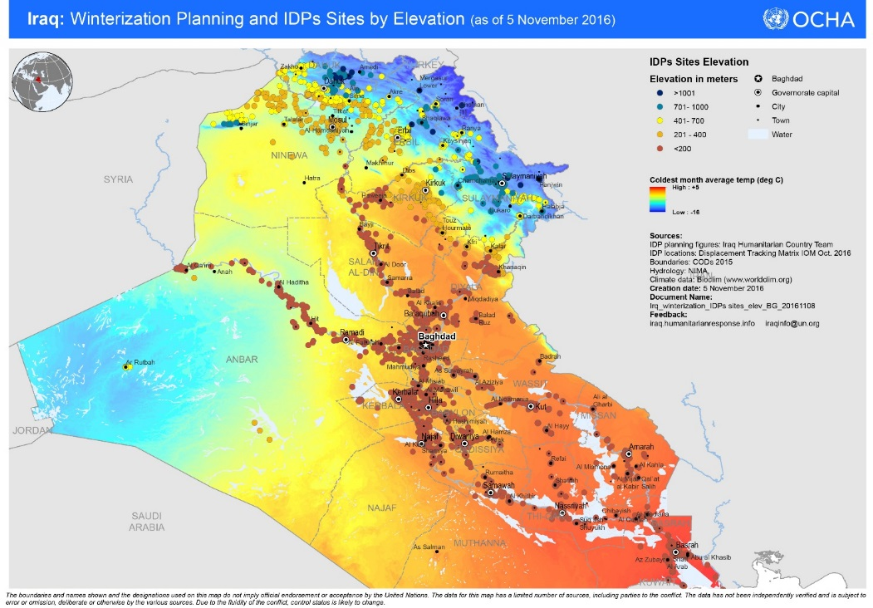

CONCEPTS OF CLIMATISATION AND SEASONAL SUPPORT

ASSISTANCE TIMEFRAMES
Late support to meet seasonal needs has resulted in the non-use or selling of assistance provided without meeting the primary needs of beneficiaries in relation to coping with extremes of climate and temperature, based on PDMs from partners and other experience. It may also mean that shelters are not suitable for the respective season, putting families at risk from extremes of temperature and other seasonal occurrences, such as snow, flooding and dust storms. Procurement for winter support should therefore start before July; procurement for summer support should start before January.
Additional replenishment support for shelter and NFI may be necessary mid-season due to flooding or dust storms that damage or destroy shelters and belongings. Ongoing and regular monitoring, management and maintenance of settlements is required to ensure that conditions remain safe, healthy and hygienic, and supportive of adequate shelter and access to basic services.

TARGETING
Shelter climatisation assistance should be provided to all families with increased seasonal vulnerability arising from residing in sub-standard shelter conditions. Where possible, a proportion of assistance should also be provided to vulnerable host community families (e.g. 10-20%).

Examples of Shelter Vulnerability
- Shelters with no windows / doors; openings are unsealed
- Shelters with poor or leaking roofs
- Overcrowded shelters (less than 3.5m² covered living space per person); shelters shared by multiple families
- Shelters with inadequate water and sanitation facilities and other basic infrastructure to meet minimum standards for the number of occupants
- Shelters with no segregated space for men and women that ensures privacy

Aim of Shelter Climatisation Assistance
To ensure affected households reside in adequate shelter, with protection from the elements and climatic extremes.

Examples of Shelter Climatisation Assistance
Modality of implementation may be in-kind or cash-based
- Distribution of Emergency Sealing Off Kits (ESOK)
- Full Sealing Off
- Rehabilitation / Durable Upgrade
Note that in line with the agreed inter-cluster methodology on integrated Shelter-WASH, the WASH facilities at shelter / household level are undertaken as part of shelter activities, while WASH actors focus on community-level networks and infrastructure.
For more information, see Shelter Cluster Iraq Technical Guidance Notes on Adequacy of Shelter; Unfinished and Abandoned Buildings and Emergency Sealing-Off Kits, accessible here:
https://www.sheltercluster.org/response/iraq
Seasonal NFI support assistance should be provided to vulnerable populations following a needs assessment with a clear vulnerability criteria.

Examples of NFI Vulnerability
- Families with no source of income
- Families lacking items of suitable quantity or quality to sufficiently assist with eating, cooking and sleeping (relative to shelter / settlement typology)
- Families or individuals lacking the means to maintain safety, health and well-being during extremes of temperature or exposure to climate
- Families or individuals lacking the means to maintain safety, health, well-being, privacy and dignity
Special support should be provided with families that are composed of:
- Female head of household
- Child head of household
- Disabled head of household
- Elderly head of household
- Large family (8 members or more)
- Low or no source of income
- Families with chronically ill/ disabled members
- Households with pregnant / lactating women

Aim of Seasonal NFI Support
To ensure affected households have sufficient items to support protection from the elements and maintain safety, health and well-being during extremes of temperature or exposure to climate.
Examples of NFI seasonal support assistance:
Modality of implementation may be in-kind or cash-based
- Mobile NFI Kit
- Basic NFI Kit
- Winter NFI Kit
- Summer NFI Kit
- Winter Top-Up
- Summer Top-Up
For more information, see Shelter Cluster Iraq Technical Guidance Note on NFI Assistance, accessible here: https://www.sheltercluster.org/response/iraq

Pages 16 – 17 of Selecting NFIs for Shelter, IASC 2008 provides a list of possible Cold Climate NFIs, while 18 – 19 covers Hot and Humid and lastly 20 – 21 concludes with Hot and Dry.
https://www.sheltercluster.org/sites/default/files/docs/Selecting%20NFIs%20for%20Shelter%202009.pdf
The Shelter Cluster has published a menu of Summer Activities for Shelter & NFI Partners found here:
https://www.sheltercluster.org/iraq/documents/menu-summer-activities-shelter-nfi-partners

SUGGESTED SEASONAL SHELTER AND NFI ASSISTANCE
The diagram below summarises recommended Shelter and NFI assistance that contributes to seasonal support. It is assumed that affected households will already have received basic Shelter and household items (e.g. Basic Emergency Shelter Kit or Basic NFI Kit) but that this is insufficient to ensure health, safety and well-being during extremes of temperature and weather. Recommended seasonal items (e.g. tent liners, carpets) to be included as part of a kit have been suggested.
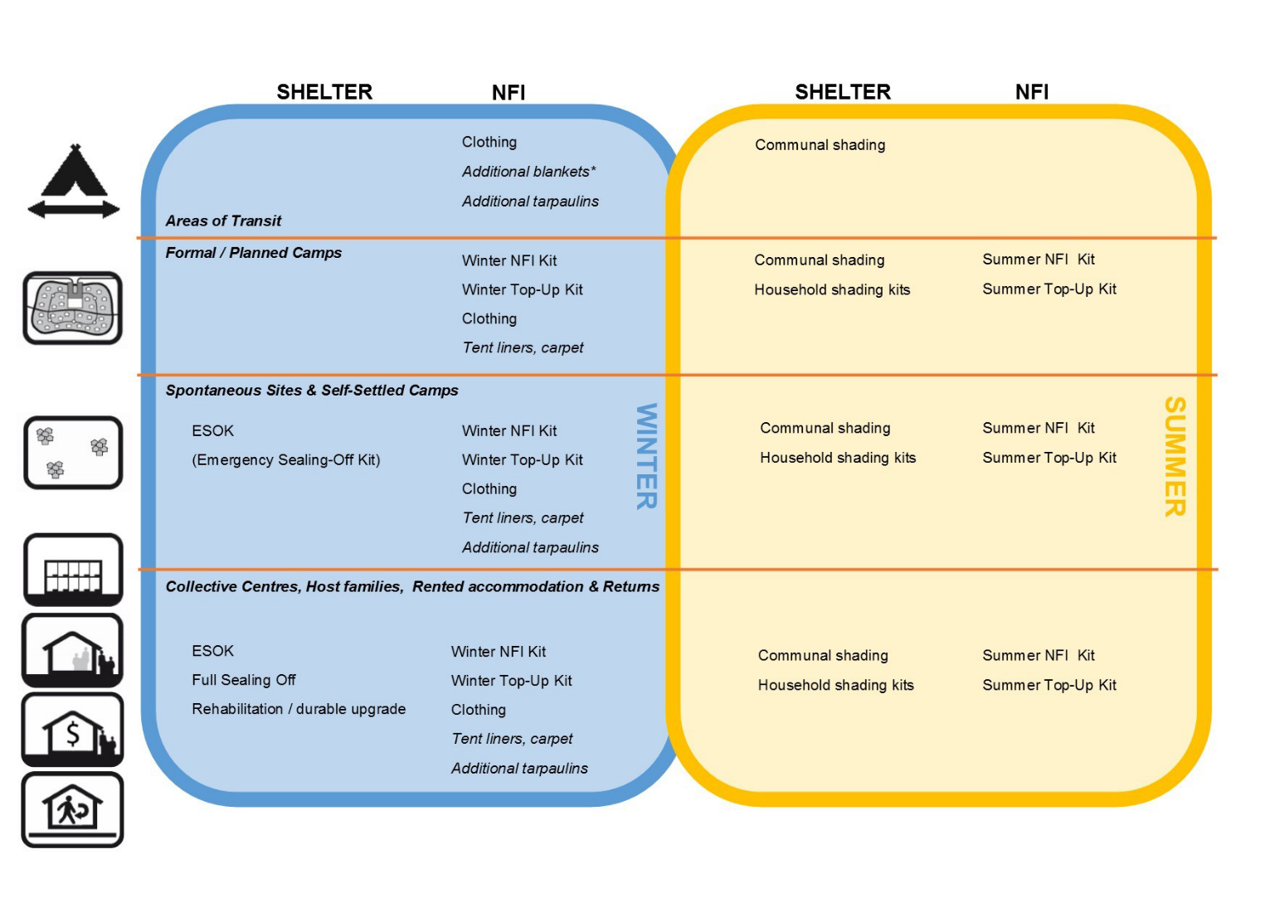

KEY CONSIDERATIONS

Fire Safety
Appliances should have a child safety switch or mechanisms to avoid tipping or burning if touched; fire extinguishers are provided; in buildings, fire alarms should be provided. Training in fire prevention and firefighting for households and settlement management representatives is strongly recommended, in coordination with CCCM actors. Gas appliances are not recommended for use in tents without floors. For more detailed information, see Shelter Cluster Iraq: Technical Guidance Note on NFIs (sections on stoves / cookers and heaters; Annexes)

Ventilation
Agencies working in Shelter and NFI in abandoned and unfinished buildings should check that it is possible for households to open some windows in the summer months to promote cross ventilation. Agencies may also consider the supply of agriculture netting material, which may help to promote privacy while promoting cross-ventilation. Ventilation of cooking stoves and cooking areas, and of heaters / heated spaces is recommended.

Mosquito Nets
In many areas of Iraq summers are too hot and dry for mosquitoes. However, some areas experience higher humidity, particularly in the south (but also in some areas of the north), and mosquito nets may be considered in summer seasonal support programmes, in coordination with Health actors. Other support can be provided in the way of fine mesh or netting material (mesh or netting) to allow construction of insect screens for openings on shelters.

WASH items, water-borne disease and hygiene health and safety
Most of the WASH related items and actions are needed throughout the year and are not specific to season. However, a specialised WASH item that can be considered for distribution/installation in preparation for winter is a heater for bathing water. Given the high safety risks, locally-made immersion water heaters, and kerosene heaters are not recommended for use. Solar or wall mounted electrical installations are recommended if deemed feasible. Any installation must be undertaken in consultation with Shelter-NFI and CCCM Cluster/partners, and any relevant camp administration or management structures. For more detailed information, see Shelter Cluster Iraq: Technical Guidance Note on NFIs
Shelter plays an important role in maintaining the health of its inhabitants, but conversely can also exacerbate issues if not addressed in an integrated manner with CCCM, WASH and Health actors. In winter, families may not wash clothes and fabrics as often, and they may not dry sufficiently. Shelters are increasingly enclosed, as reducing cold draughts also means reducing ventilation, leading to stale and damp internal environments. This leads to a marked increase in respiratory illnesses during winter as well as scabies. Support from Shelter and NFI actors during such preparedness and response activities for WASH-related illnesses (e.g. cholera, scabies) may be required - for example, in the distribution of additional NFI kits to replace those that may have been contaminated, in the dissemination of key health and hygiene information, or the installation of facilities / features that support good health and hygiene.

Flooding
Flooding can reduce access to sanitation facilities, and can result in standing, stagnant water which will lead to unhygienic conditions and attract vectors. Preparedness and response activities would include digging, deepening and clearing drainage channels in public areas (e.g. paths) as well as training in digging and maintaining drainage around shelters, to ensure rain water flow to either natural drains or municipal drains. To assure better access to WASH facilities, gravelling of roads leading to WASH facilities (for desludging and water trucks) or of pathways leading towards WASH facilities from tents (for individual users) could also be considered. Activities should consider colder temperatures in northern areas, in addition to higher rainfalls in southern areas, often requiring flood mitigation measures at both community and household levels, comprising surface water drainage, ballast to raise areas at risk and sandbags surrounding family shelters.

Settlement Conditions
Maintenance of camp/centre infrastructure: solid waste disposal in camps could block surface water drainage in winter and there is a need to work on campaigns to ensure residents are aware of the serious consequences for not keeping the camps clean. Camp Management could ask camp residents to participate actively with focal points, to make sure that camps are free of refuse on the ground. There is a need for evaluation of flooding risks in the sites and settlements: if risks are present, there is a need to identify alternative locations within the same sites/settlements, or elsewhere to be available at short notice. It is also important to strengthen the system to gather information on the maintenance of shelter so that timely action can be taken. Accessibility issues, such as the deterioration of roads and flood risks from snow melt must be monitored and improved.

Evaporative Water Coolers
Although these may be an effective solution for summer cooling in the dry climate of Iraq, the restricted funding environment and supply limitations of both water and electricity in many locations (expected to increase in severity), means they should be considered very carefully for targeted distribution where sufficient resources allow their effective use. In general, for camps and collective facilities, cluster partners are encouraged to only provide them for communal facilities such as schools/health facilities, taking direct responsibility for the increased water and electricity requirements as needed. Coordination with respective clusters, settlement management authorities and the government is strongly recommended.

SEASONAL SHELTER ASSISTANCE

How to Winterise Tents and Support Fire Safety
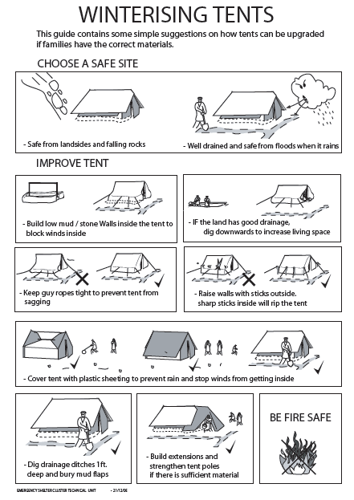
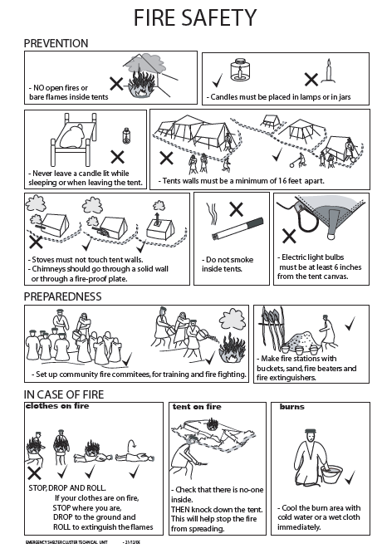
References: http://humanitarianlibrary.org/channel/iraq-shelter-housing-nfis

How to Seal Off Shelters and Buildings
For more information, see Shelter Cluster Iraq Technical Guidance on Unfinished and Abandoned Buildings [1] (Tool C: Harmonised Scope of Works) and Emergency Sealing-Off Kits (ESOK): https://www.sheltercluster.org/response/iraq
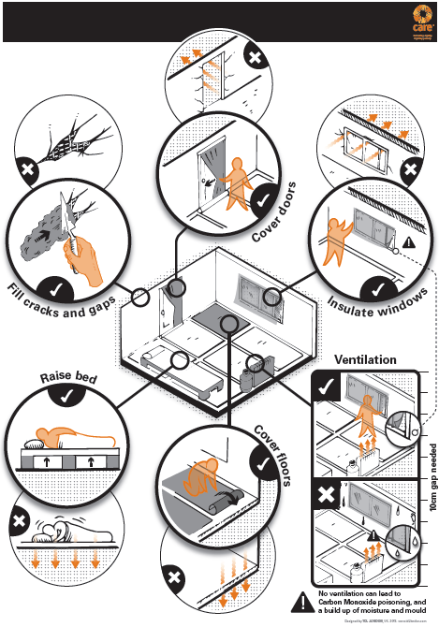

Reference: http://humanitarianlibrary.org/channel/iraq-shelter-housing-nfis (available in English and Arabic)
Acknowledgement: CARE/TDL London

How to Keep Cool During Summer
References: Shade Nets: Use, deployment and procurement of shade net in humanitarian relief environments, MSF & Shelter Centre, 2006
http://www.humanitarianlibrary.org/resource/shade-nets-use-deployment-and-procurement-shade-netting-humanitarian-relief-environments-0
Acknowledgments: MSF & Shelter Centre; Michael Waugh, NRC; AAF; IOM; NRC

Shading
Shading can be constructed out of a variety of materials, from mesh netting and plastic sheeting to plywood and corrugated galvanised iron sheeting, among others.
In hot climates such as Iraq, shade has important implications for improving people’s health, protecting from UV radiation and preventing dehydration and overheating which can pose a particular risk to vulnerable people, such as the elderly and young children. Shading can also protect structures such as water tanks (reducing evaporation and the degrading effect of UV light on chlorination), supplies, and equipment, such as vehicles. A properly constructed, framed shade over a shelter prevents degradation of tent and tarpaulin materials by UV radiation, and reduces the internal temperature of the shelter, while encouraging air flow and thus ventilation of the shelter.
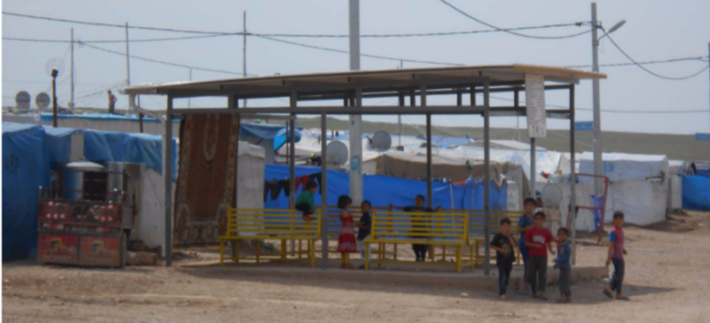
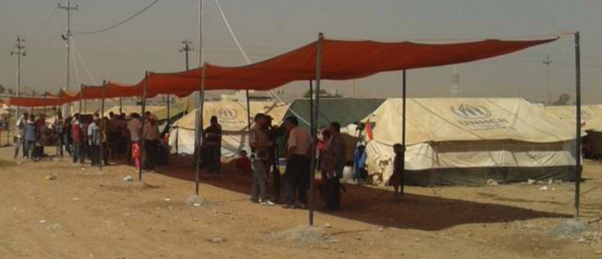
It also supports the effective use of external areas. Creating communal shade allows additional space for working and socialising, while shaded extensions to shelters permits some household functions more space outside. The use of shading material for fencing supports security and privacy. It can also be used to construct windbreaks, aid circulation routes and cover waiting areas, such as around health centres, water collection points and distribution areas.
Photos: Courtesy of NRC Iraq

HOUSEHOLD SHADING KIT
# | Item description | Unit | No. | Unit cost / $ | Cost / $ | Specifications description | Notes
1 | Shading material* | m² | 27 | $1.5 /m² | $40 | (Example) Sunshade net: 100% HDPE; width 4.5 x 6m length; shade rate 70-80% | Basic shading material for domestic use NOT for industrial agricultural purpose as it is much higher in cost. Either Black or Green in colour.
2a | Timber lengths | piece | 2 | $4 | $8 | 2.3m long. Section size 65mm x 65mm nominal | Select either 2A or 2B
2b | Timber poles | piece | 2 | $6 | $12 | 2.3m long. Section size 50mm diameter nominal | Select either 2A or 2B
Other items that may be included are tools (or a Community Toolkit), nails, rope and wire.
EXAMPLE COMMUNITY SHADING KIT (for a shaded cover of 41m²)
# | Item description | Unit | No. | Unit cost / $ | Cost / $ | Specifications description | Notes
1 | Shading material* | m² | 150 | $1.5 /m² | $225 | (Example) Sunshade net: 100% HDPE; width 4.5 x 6m length; shade rate 70-80% | Basic shading material for domestic use NOT for industrial agricultural purpose as it is much higher in cost. Either Black or Green in colour.
2a | Timber lengths | piece | 12 | $4 | $8 | 2.3m long. Section size 100mm x 100mm nominal | Select either 2A or 2B
2b | Timber poles | piece | 12 | $6 | $12 | 2.3m long. Section size 100mm diameter nominal | Select either 2A or 2B
3 | Ridge poles | piece | 2 | $ | $ | 5m long; 150mm wide
4 | Rope | roll | 1 | $30 | $30 | Nylon or similar, diameter. 9 to 12 mm diameter. Woven with 2 or 3 strands, with the possibility of being unravelled. Length: 200m, in a roll. Preferred colour: Black / dark green.
5 | Tent pegs or stakes | piece | 28 | $0.50 | $14 | Tent pegs, 200 to 300 mm length after bending; made of iron reinforcing bar of 10 mm diameter, with a hook bent on one end, “candy cane” shape, or a cross shape.
6 | Strong twine | m | 6 | $0.5 | $3 | 6mm; for stitching
7 | Nails | kg | 1 | $2 | $2 | Steel. Supplied in a sealed bag. Length: 75mm (3”); Diameter: 3 mm
8 | Community toolkit | kit | - | - | $90 | (Example contents) Handsaw, shovel, wheelbarrow, claw hammer, pickaxe

*Shelter grade tarpaulin can be used in place of the sunshade net specified above with improved structure to support the increase in weight.
The table above gives an example of the materials needed for the construction of a community shade structure for clinics of feeding centres, for example. Community shading kits should be tailored in size, design and composition to address identified needs, as well as coordinated and consulted with site / settlement management authorities and end users.

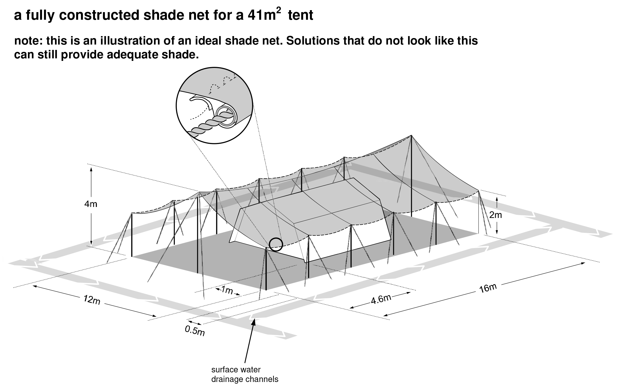
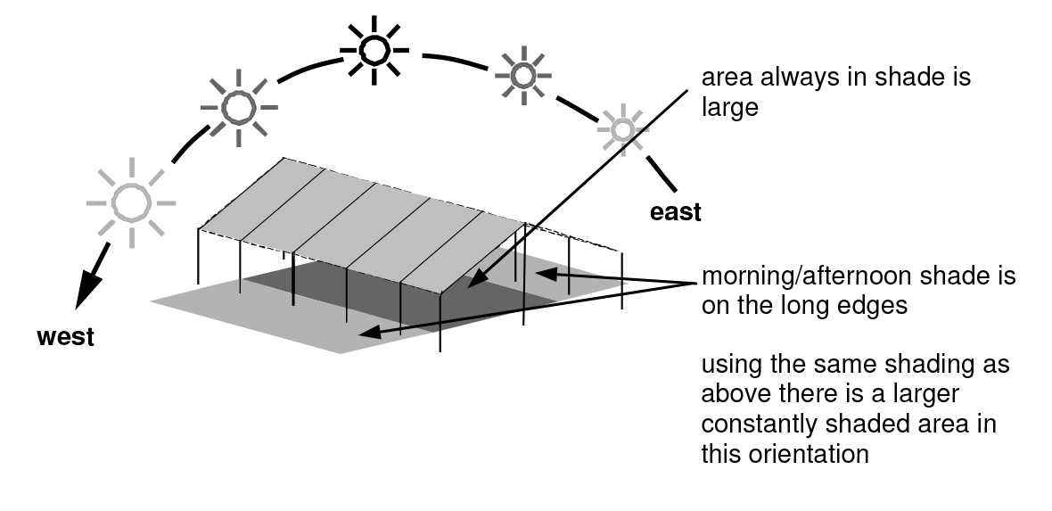
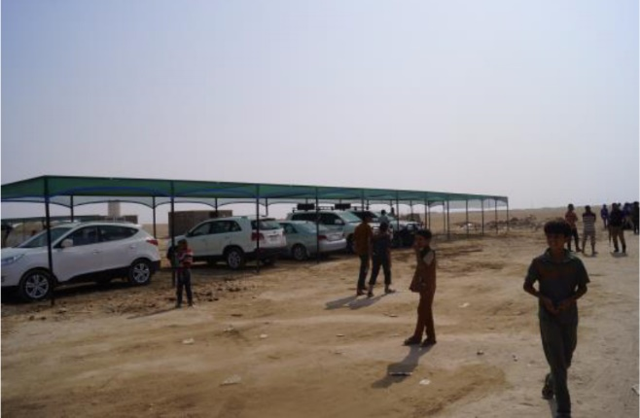

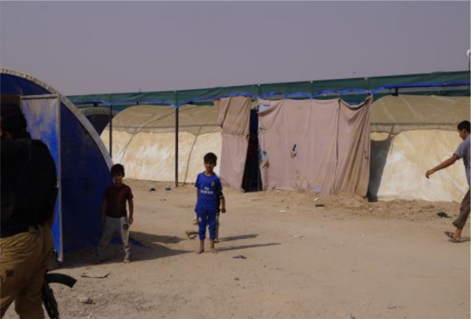
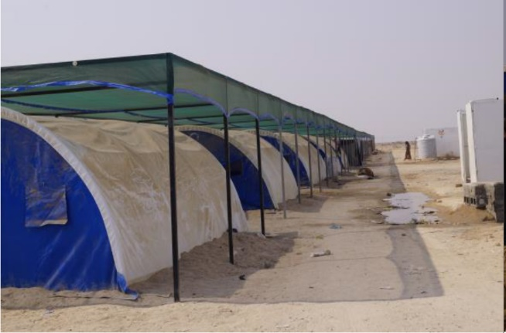

Photos: Courtesy of AAF/IOM
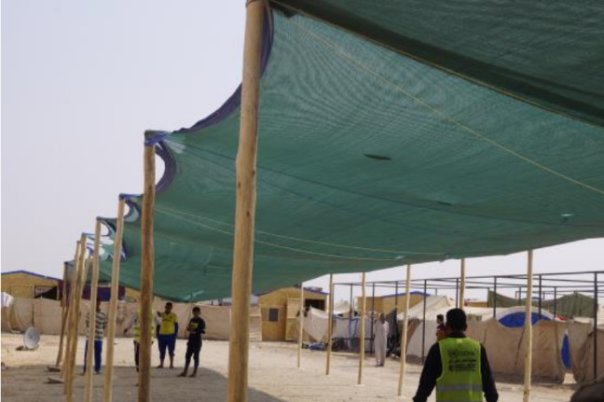

Photos: Courtesy of AAF/NRC

Fixing Shading Material
The guide produced by ICRC & Oxfam outlines the best practices for fixing plastic sheeting. Some examples in the guideline on how to spread the load to prevent the plastic sheeting from pulling through are:
Fixing to Timber
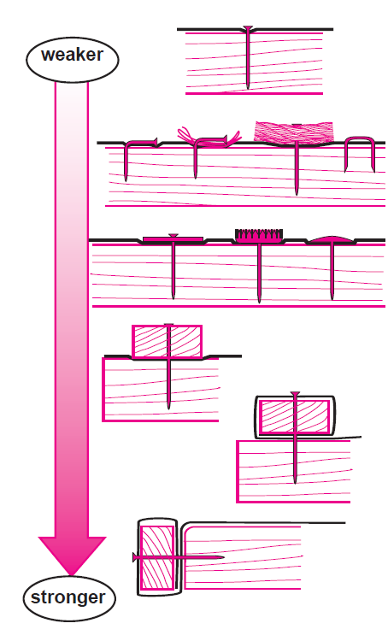
Timber battening is good to spread the load.
Plastic sheeting should be folded over on itself at connection points.
Standard nails can be improved using washers or battle caps. Alternatively, domed head nails can be used.
Standard nails can be improved by bending or nailing them through folded plastic sheet or rope. U-shaped fencing pins can be used.
Plastic sheeting is best fixed to spread the load along the (smoothed) edge of the supporting structure.
Standard nails will easily pull through plastic sheeting as they have small heads.
Reinforcement Bands
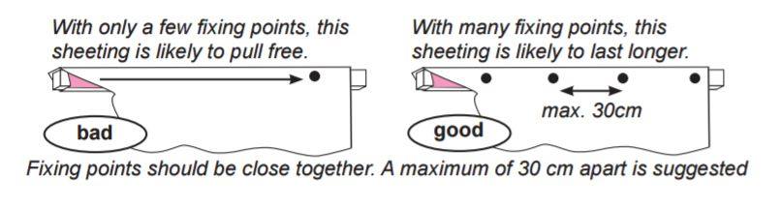If reinforcement bands are available, fixing should pass through the bands to add strength to the fixings.

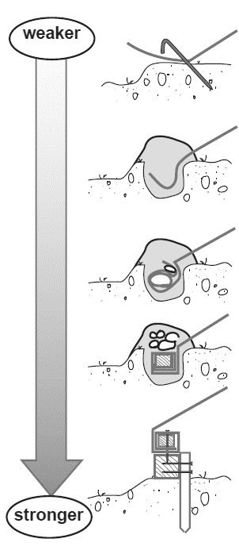

Fixing to the Ground
When plastic sheeting is connected directly to the ground, 50cm of additional plastic is required on each side for burying in trenches. If timber is available, then the plastic sheeting can be nailed to timber runners that are pegged to the ground (or connected to the foundations).
Whilst sandy soils will not grip the plastic sheeting as well as other soil types, it may be very difficult to dig trenches in some rocky soils. Choosing a method for fixing the sheeting to the ground therefore depends upon the soil conditions as well as the availability of materials.
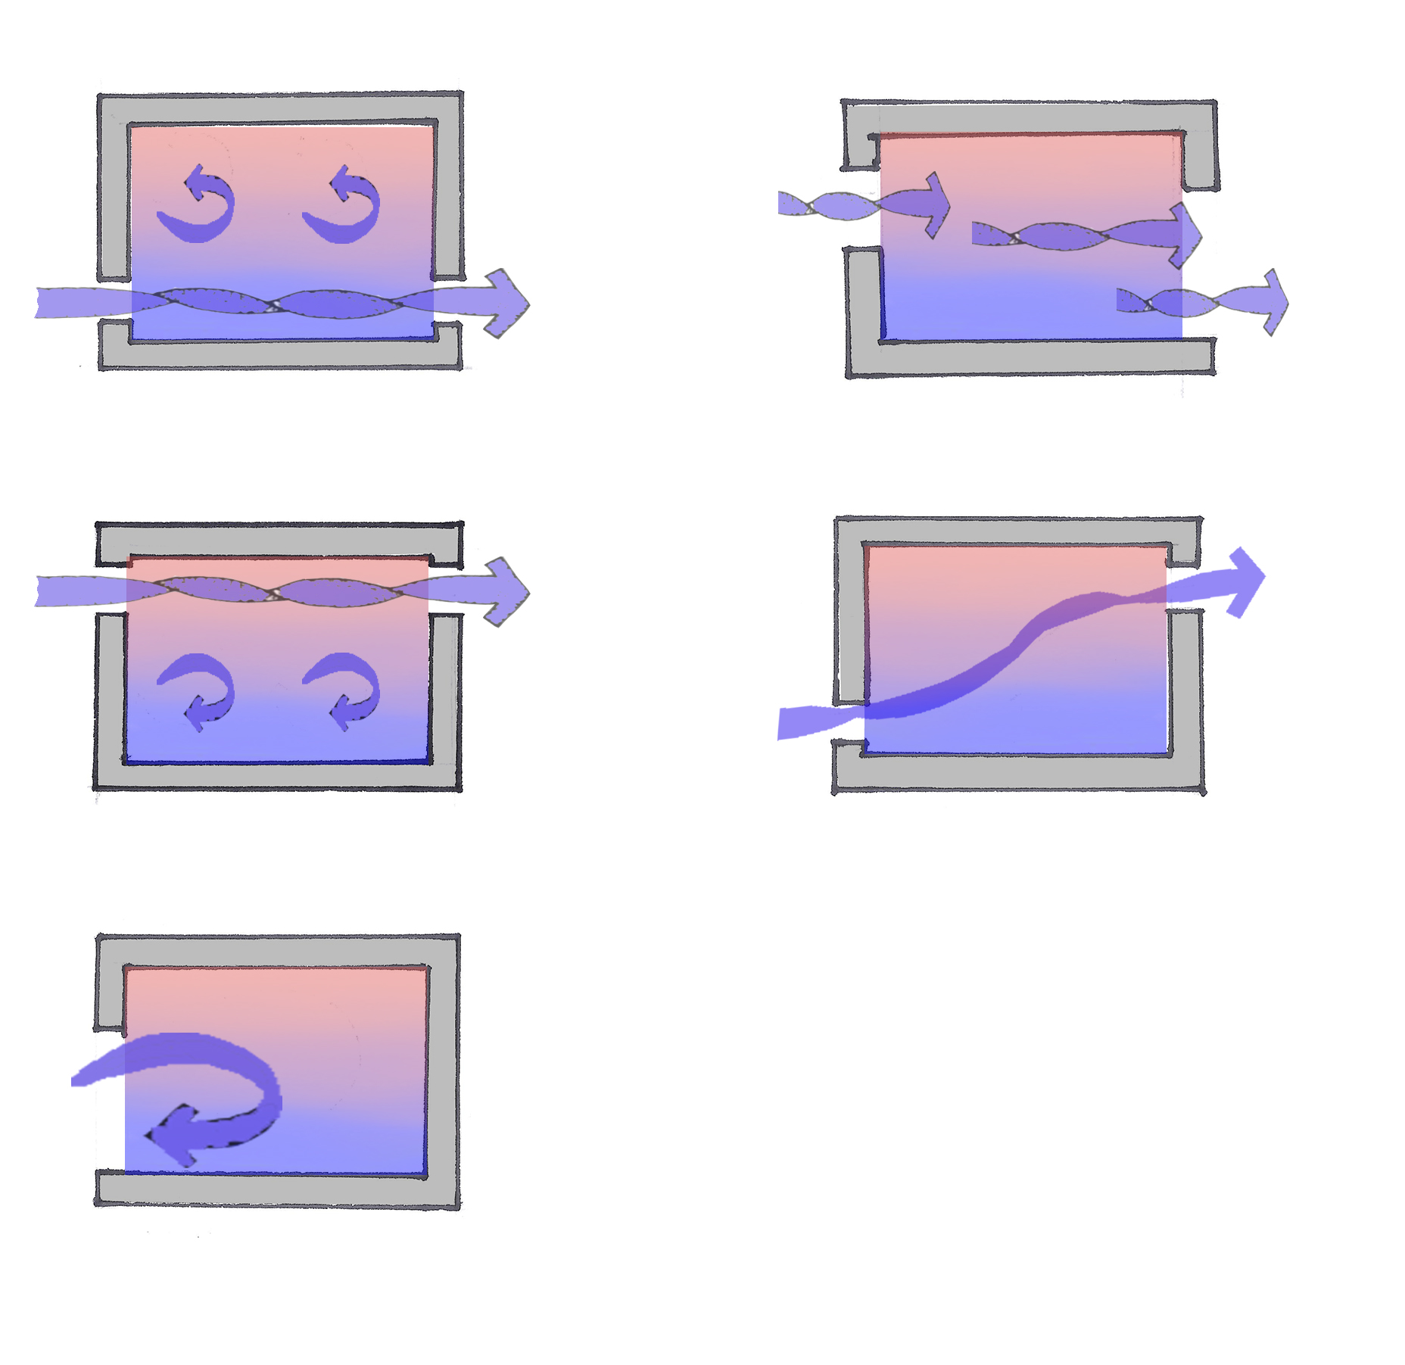
Cross Ventilation
Making the most of natural breezes to maximise their cooling properties can assist in making internal spaces more comfortable during hot weather, as well as ensuring that living and sleeping areas are properly ventilated to eliminate damp, odours, fuel emissions and other pollutants, and stale air, which assists in maintaining good health. Good ventilation results from 1) building / shelter location, orientation and massing and 2) sizing and placing of openings. As the direction of the prevailing wind (and associated problems, such as dust storms) may change throughout the year, the ability of inhabitants to adjust openings to encourage breezes or prevent draughts is recommended.
A general rule of thumb is that the area of the openings should be around 20% of the floor area of the space to be ventilated, with the inlet aperture matching the outlet aperture in size. A smaller inlet and larger outlet will increase the air flow into the space, enabling the volume of air to be changed more regularly and increasing a breeze’s cooling properties. Placing openings across from each other but not directly opposite maximise the area that can be effectively ventilated / cooled. Locating air inlets low down (where air is coolest) and outlets high (where air is warmest) increases ventilation through the stack effect.
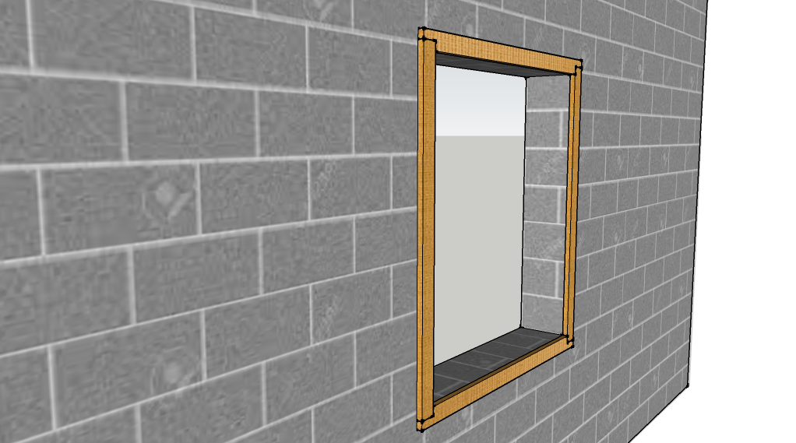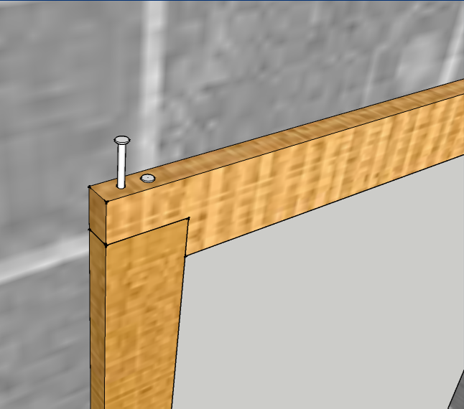
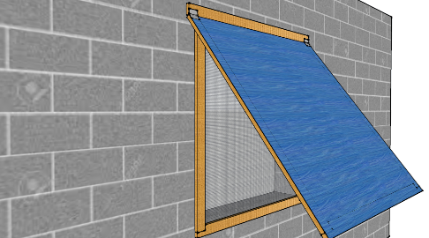
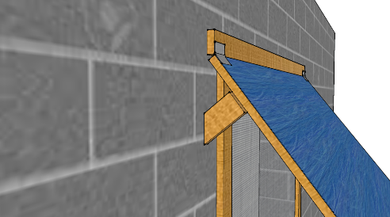
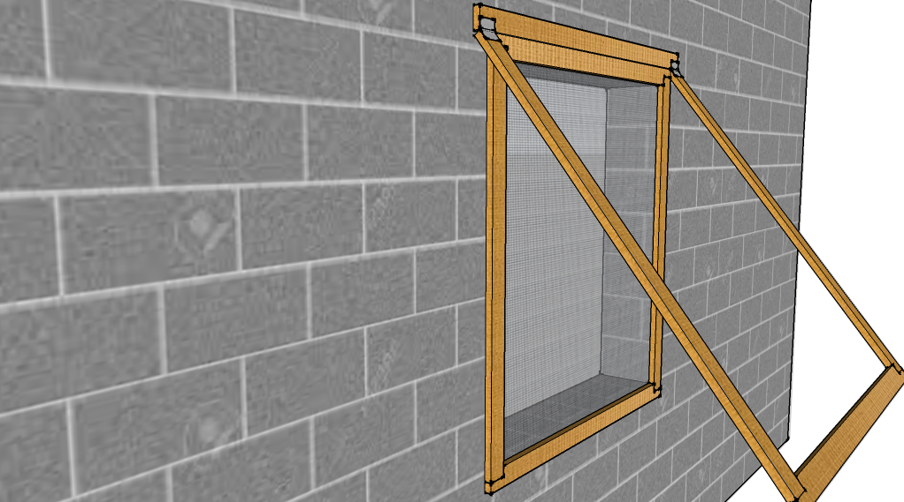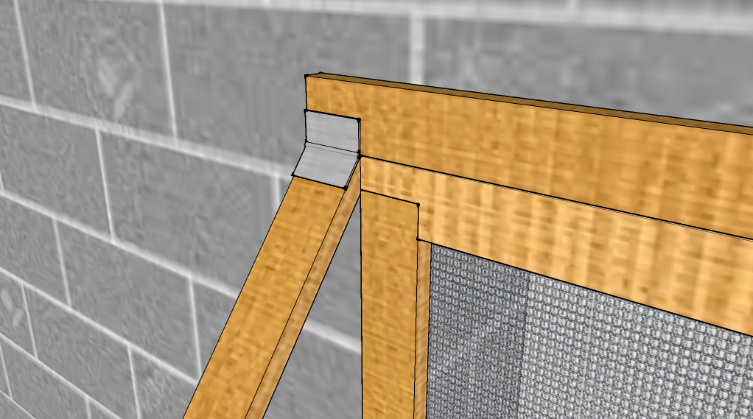

SEASONAL NFI ASSISTANCE

Cold Climates
During winter, the following should be considered for general household support:
- Protection from cold, e.g., warm clothing
- Insulation from ground, e.g., mattress
- Food preparation and hygiene, e.g., cook sets and utensils
- Heating and cooking, e.g., stove and fuel
The Shelter Cluster is recommending the following for Winter BNFI kits:
Item | Cost per Unit ($)
Shelter-Grade Tarpaulin | 15 | Essential 8 items part of the BNFI kits  Total price of BNFI Kit is around 245$
Mattresses x 6* | 16
Blankets x 6* | 8
Kerosene or Gas Cooker / Stove | 17
Kitchen Set | 39
Solar Light / Hand Crank Torch | 5
Basic Hygiene Kit | 24
Water Jerry Can (plus Kerosene Jerry Can if Kerosene Cooker / Stove is supplied) | 1.4
Kerosene Heater | 50 | Essential 2 seasonal NFI items
Kerosene Jerry Can | 3.5
Thermal Roll Mat | 15.8 | Additional seasonal items as required
Carpet | 18
Winter Clothing Kit | 25
*The Cluster encourages partners with the logistical capacity to distribute blankets and mattresses as per number of individuals in a household to do so.

Warm Climates
During summer, the following should be considered for general household support:
- Protection from sun, e.g. loose fitting clothes
- Insulation from ground, e.g. mat or mattress
- Food preparation and hygiene, e.g. cook sets and utensils
- Facilitate outdoor activities, e.g. covered cooking area
The Shelter Cluster is recommending the following for Summer BNFI kits:
Item | Cost per Unit ($)
BNFI Kits with bedsheets instead of blankets | 245 | Essential 8 items same as above
Cool Box | 26 | Essential 2 seasonal NFI items
Extra Water Jerrycan | 1.4
Shading Kit | 60 | Additional seasonal items as required
Clothing Kit | 20
Rechargeable fans | 28

Fans
For camps, the Cluster does not recommend distributing fans or evaporative water coolers to individual households. Communal shading areas and the use of evaporative water coolers in communal spaces such as health clinics or child-friendly spaces are the recommended options. However, partners must take into consideration whether the electricity generation capacity in the camp can accommodate the extra load.
For out of camp, due to restricted funding and inconsistent supply of electricity, the Cluster also does not recommend distributing fans or evaporative water coolers to individual households. However, partners with the capacity to do so should assess beforehand whether the households have regular access to electricity / enough water to keep them functional.

CASH-BASED ASSISTANCE
The Shelter-NFI Cluster and the Cash Working Group (CWG) recommend the adoption of cash-based interventions, where feasible, to meet the seasonal shelter and NFI needs of affected populations. The use of cash interventions is in line with the principles of accountability to affected populations as it respects freedom of choice to address self-identified needs with dignity. It is also in line with the broader move by the humanitarian community in Iraq to adopt cash-based assistance modalities in areas where markets are functioning and accessible.
Currently, the CWG provides multi-purpose cash assistance (MPCA) to highly vulnerable families to meet critical basic needs in the form of one-off emergency cash transfers, and an additional two transfers for the most vulnerable households. Transfer values are based on an agreed survival minimum expenditure basket that includes costs for rent and other basic shelter needs. Partners are encouraged to work closely with the CWG to ensure shelter-NFI cash interventions are aligned with multi-purpose cash and other sector-specific cash projects being implemented in Iraq. The CWG is available to provide technical assistance in the design and operationalisation of shelter-NFI cash interventions as needed.
Cash interventions can be incorporated into climitisation and seasonal support in the following ways:
Option One: Unrestricted Seasonal Top-Up (Preferred)
Seasonal assistance is provided as an unconditional cash transfer “top-up” to vulnerable households already receiving multi-purpose cash assistance (MPCA). When delivered in combination with MPCA, unconditional seasonal top-ups ensure households have sufficient protection from extreme temperatures while also limiting the risk that cash intended for seasonal support is spent on unmet basic needs. Partners are encouraged to work closely with the CWG to establish referral systems and to ensure shelter-specific vulnerabilities are appropriately considered in CWG targeting criteria. The following are recommended transfer values and timeframes for distribution:
Recommended Transfer Values: Unconditional Cash Assistance
 | Summer Support | Winter Support
Transfer Value | 20 - 90 | 20 - 75 USD
Timeframe | Mar - Oct | Nov, Dec, Jan, Feb

The ranges above were calculated based on adding the 2 essential items as the minimum and the 2 most expensive items for the maximum.
Option Two: Restricted Seasonal Voucher
Vulnerable households are provided with vouchers redeemable only for a restricted list of seasonal shelter items at selected vendors. Where possible, it is preferable to establish a large network of local traders that are easy and safe to access, particularly for conflict-affected families and vulnerable groups such as the elderly and disabled. In cases where this is not possible, a voucher fair is a practical alternative. A voucher fair imitates a market by bringing traders to an organised space where they display products and beneficiaries use vouchers to purchase the goods they need. Partners should consider the cost of transportation to/from voucher distribution points, local markets and voucher fairs when designing their programmes. Transport costs can be met through unconditional cash transfers. Partners are encouraged to work closely with the CWG to ensure restricted voucher projects are aligned with other cash-based interventions.
Recommended Transfer Values: Restricted Seasonal Voucher
 | Summer Support | Winter Support
Transfer Value | 270 USD | 300 USD
Timeframe | Mar – Oct | Nov, Dec, Jan, Feb
The values above were calculated based on adding the cost of the BNFI kit with the cost of the 2 essential seasonal items.
For cash-based interventions, transfers must be done through vulnerability-based assessments rather than blanket targeting. Again, the Shelter Cluster stresses the importance of coordinating with the CWG to avoid duplication of efforts and to ensure alignment with other cash-based interventions.

From Shelter Cluster Iraq Technical Guidance on Emergency Shelter Kits (ESK), https://www.sheltercluster.org/response/iraq
From Shade Nets: Use, deployment and procurement of shade net in humanitarian relief environments, MSF & Shelter Centre, 2006, pp. 18-21
¹ From Shelter Cluster Iraq Technical Guidance on Emergency Shelter Kits (ESK), https://www.sheltercluster.org/response/iraq ² From Shade Nets: Use, deployment and procurement of shade net in humanitarian relief environments, MSF & Shelter Centre, 2006, pp. 18-21 From Shelter Cluster Iraq Technical Guidance on Emergency Shelter Kits (ESK), https://www.sheltercluster.org/response/iraq
Plastic Sheeting – A guide to the specification and use of plastic sheeting in humanitarian relief – ICRC & Oxfam
https://www.sheltercluster.org/sites/default/files/docs/Selecting%20NFIs%20for%20Shelter%202009.pdf Acknowledgement: IASC Emergency Shelter Cluster

