**Technical Guidance for Emergency and Early Recovery**

**Shelter Assistance**

# Table of Contents

Table of Contents 1

1. Definitions 1

2. Introduction 3

2.1 Background 3

2.2 Coordination 5

2.3 Natural hazards and design requirements 6

2.4 Shelter Strategy 7

2.5 Government response 9

3. Emergency Shelter 11

4. Household non-food items (NFIs) 11

5. Cash Response 13

6. Transitional/ Core shelter 13

6.1 Tents 13

6.2 Transitional shelter 14

6.3 NBRO core house 14

6.4 Construction codes & consensus standards 16

7. Disaster Risk Reduction / Community Awareness 16

ANNEXES 18

ANNEX 01: Background Information 18

ANNEX 02: Definitions of NFI items 19

ANNEX 03: NBRO Policy Framework 22

ANNEX 04: Descriptions of construction materials 23

ANNEX 05: Template design brief for shelters 25

# Definitions

The terminology used in this document is described below

|  |  |
| --- | --- |
| Households | The occupants of an affected house, this could include more than one family; to calculate the number of affected people / beneficiaries the number of households gets multiplied by 4.5 |
| Displaced | People that had to move away from their house due to landslide and/or unsafe site; displacement can be temporary or permanent |
| Non-displaced | People that still live in their house (partial damaged house), or live on their own plot of land in a temporary shelter (fully damaged house) |
| Evacuation centres | Locations where displaced are provided emergency shelter, these include schools, temples |
| Safe site | See evacuation centres |
| Host families | Temporary accommodation provided to displaced by neighbours, relatives or communities |
| Shelter repair kits | Standard specifications agreed in shelter working group strategy |
| NFI kits | Non Food Items standard specifications agreed in shelter working group strategy |
| Cash | Financial support instead of shelter repair/ NFI kit, often provided in return for daily labour |
| Advancement on insurance | Financial emergency assistance provided by NDRSC as part of the national insurance scheme for flood-affected houses |
| Emergency/ temporary shelter | A temporary structure which provides adequate shelter for a short period of time immediately after a disaster |
| Transitional shelter | A structure which provides adequate shelter from the emergency phase until longer term durable solutions can be provided - if required these can be dismantled and relocated, and materials reused |
| Core house | A permanent structure built to normal national standards safe against exposure to hazards, consisting of one room and a washroom |
| Permanent house | A permanent structure built to normal national standards safe against exposure to hazards |

# Introduction

The Sri Lanka Shelter Sector Working Group developed the following technical guidance for the emergency and early recovery shelter response to the May 2017 floods and landslides. This document is an annex to the shelter cluster strategy and has been developed to inform shelter and NFI practitioners. Both the Shelter Sector Working Group Strategy and this Technical Guidance are living documents and may be revised as needed.

This document aims at promoting a harmonised and effective shelter response, enabling the wide range of agencies to provide a consistent shelter approach to the affected population, to limit gaps and discrepancy in interventions and provision of shelter. This document was developed through a consultative process with the Shelter Sector Working Group partners.

The shelter interventions - and household-related items presented below - follow agreed international standards of best practice, although these might vary from agency to agency. All shelter programmes should refer and adhere to the guidance established in *The Sphere Standards* ([http://www.sphereproject.org](http://www.sphereproject.org/))*,* as well as any existing standards established by the national government, such as the National Building Research Organization (NBRO) policy framework and technical guidelines (Annex 3).

NFI kits and items mentioned in this document are based on minimum standard household size. The Shelter Sector Working Group Sri Lanka would advise agencies to use the suggested standards and specification detailed in this document. This is not an exhaustive list and other items and approaches might also be relevant to the context.

The Shelter Sector Working Group supports shelter assistance as being more than just the provision of a product. Shelter assistance should be an incremental process enabling individuals to gain access to adequate housing. This may include the provision of products (tents, tarpaulins, etc), but should also include the improvement of living conditions in collective centres, cash support to buy construction materials, hire labour or pay rent, and the provision of technical support and training to building back better and safer, including livelihood support and protection. Shelter assistance should be a flexible combination of these modalities, adapted to the local context, and based on continuously updated assessed needs, resources and capacities.

## 2.1 Background

On 25 and 26 May 2017, incessant heavy rainfall brought by the southwest monsoon triggered flooding and landslides in 15 of the 25 districts of Sri Lanka, affecting about 630,000 people. It is estimated that at least 150,000 are women and girls of reproductive age, and over 189,000 children are affected by the disaster. National authorities confirmed 203 deaths and 96 people missing. The floods and landslides destroyed or damaged over 70,000 houses and temporarily displaced 73,560 people to 354 locations with Galle, Kalutara, Matara and Rathnapura as the worst-hit districts (figure 1 – damage data as per 11 June 2017).

Figure 1: Damage data (DMC, 11 June 2017)

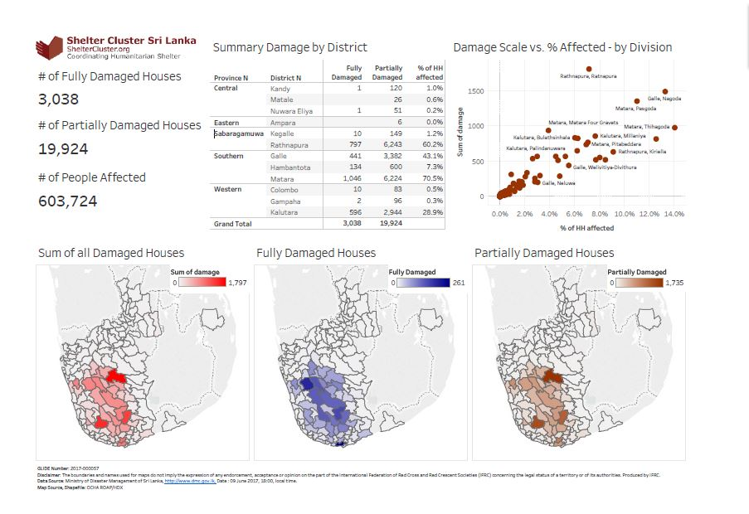

While the majority of those displaced have been able to return to their houses, there remain a significant percentage of displaced families whose houses are in landslide prone areas, and alternative solutions for longer term safe housing will need to be sought.

Upon the request of support by the Government of Sri Lanka to the United Nations, the HCT launched an Emergency Response Plan (ERP) requesting 22.7 million USD to assist the needs of 374,000 people in 7 worst affected districts and targeting 4 priority sectors (Shelter, Food, Health and Wash). The Shelter Sector requested 6.5 million USD under the ERP, and has been able to provide most NFI needs, as well as emergency and temporary shelter assistance, including through funding outside of the ERP (figure 2, updated 29/8/2017).

Figure 2: Response data (29 August 2017)

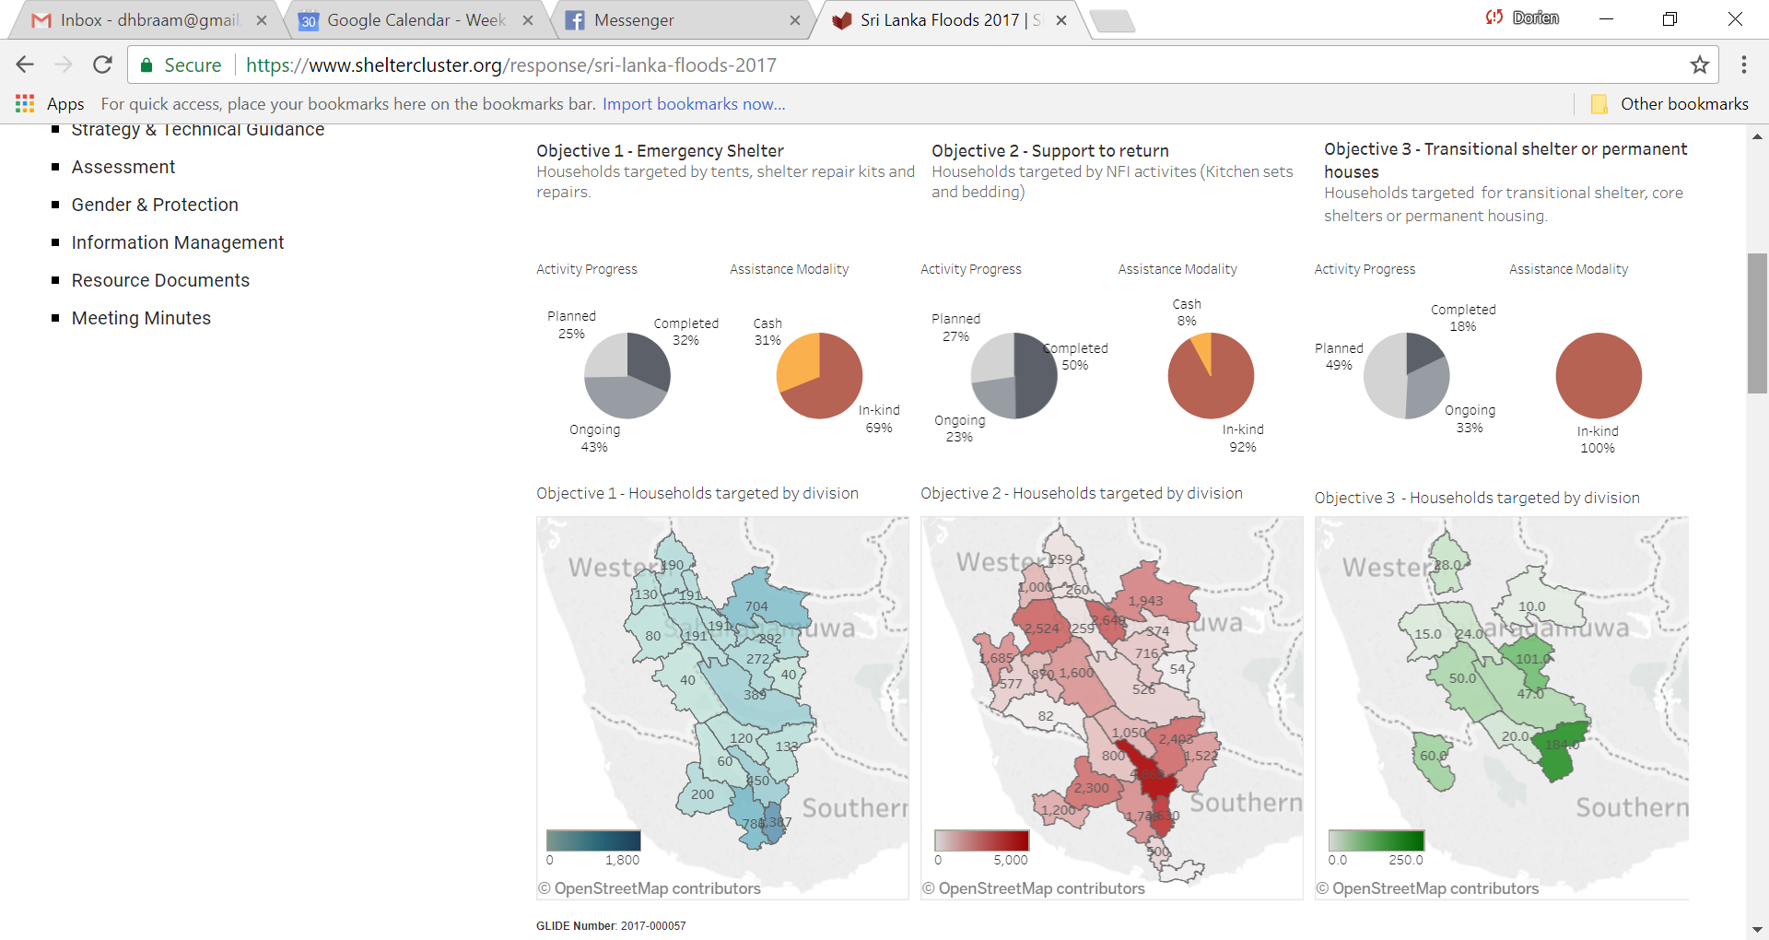

## 2.2 Coordination

The legal and institutional structure for disaster management in Sri Lanka is derived from the Sri Lanka Disaster Management Act No. 13 of May 2005. Following the Act, the National Council for Disaster Management (NCDM), a high-level oversight body was established to provide directives to DRM efforts in the country. The Disaster Management Centre (DMC) was established in July 2005, to implement the directives of the NCDM. The Ministry for Disaster Management (MoDM) was initially established in November 2005, mandated to lead on all aspects of Disaster Risk Management.

MoDM comprises of the DMC, Department of Meteorology, National Building Research Organization (NBRO) and the National Disaster Relief Services Center (NDRSC) to implement its core functions. An implementation mechanism consisting of the National Disaster Management Coordinating Committee (NDMCC), was set up to achieve coordination of DRM with key Ministries, departments and other stakeholders[1]. Similar coordinating committees have been established at the District, Divisional and Grama Niladhari levels.

Following the May 2017 floods and landslides, the Humanitarian Country Team (HCT) under leadership of the Resident Coordinator (RC) decided to activate sector working groups to better coordinate the response. The Shelter Sector Working Group coordinates shelter response agencies at national level, coordinating closely with both NDRSC and NBRO. The working group lead agencies meet on average every other week in the intersector meeting to discuss cross-sector issues. In addition, the Shelter Sector Working Group and the WASH Sector conduct co-led meetings to streamline and support partner responses.

At district level, Shelter Sector focal points have been appointed (District Focal Points: Matara - Save the Children; Ratnapura - World Vision; Kaluthara & Galle – UNHabitat). These are responsible for coordinating gaps and activities at district level with sub-national authorities, in collaboration with the district Government Agent (GA) (figure 3). At Divisional Secretariat (DS) level, organizations need to coordinate with the DS and Grama Niladhari officers (GN), including regarding prioritizing assistance to vulnerable households and people in coordination with the protection sector.

*Inclusion: http://www.ifrc.org/Global/Documents/Secretariat/Shelter/All-under-one-roof_EN.pdf*

Figure 3: Coordination and IM flows

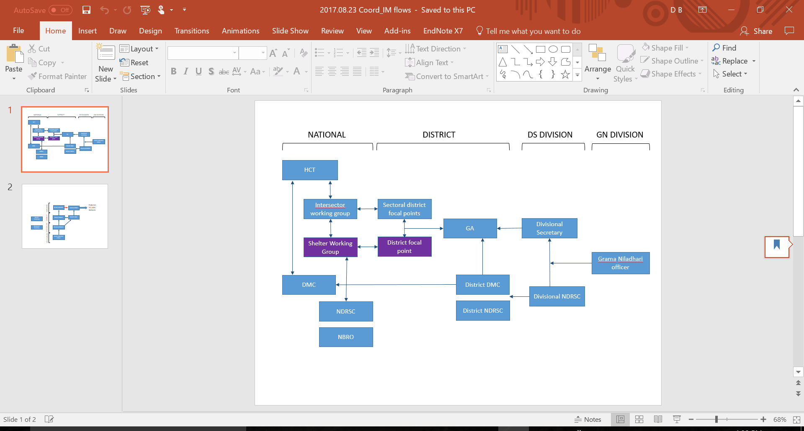

**2.2.1 Information Management**

The GN officer collects information on affected households and damage in the GN division, which is then forwarded to the DS and NDRSC focal points. Through these, the information of all divisions is collated at district level at the GA office and district unit of DMC, before forwarding to NDRSC and publication by DMC at national level (figure 3). Government response data is available with the NDRSC.

The Shelter Sector Working Group is supported by two Information Management (IM) officers, collecting data at both national and district level, identifying challenges in data collation and distribution between DS and national level, primarily caused by delays in data forwarding.

## 2.3 Natural hazards and design requirements

Sri Lanka has a tropical climate and two monsoon seasons, *maha* from December to March and *yala* from June to October. More intense monsoon rains associated with climate change mean that floods are now a regular occurrence, made worse in some cases by deforestation and erosion, which also contribute to landslides. As Sri Lanka’s population has grown, more people have set up home in vulnerable areas close to rivers. The main natural hazards are cyclones and tornados, and the risks associated with them are increased by factors including deforestation, soil erosion, coastal degradation and increased pollution. Changes in the frequency and intensity of extreme climatic events, sea level rise and storm surges related to climate change are the major concern. Together with riverbed and coastal erosion, disappearing forests and changes in land use, they are likely to increase the threats to communities and their livelihoods.[2]

The geographical features of the four most heavily affected districts in the May 2017 disaster – Rathnapura, Galle, Matara and Kalutara – influenced their vulnerability to landslides, further exacerbated by the landscape use, such as cutting failures and deforestation. Risks can be determined based on an assessment of the local/regional characteristics (Annex 1). Buildings need to include appropriate consideration of the terrain where they are located, as well as their performance when subjected to natural hazards, including adaptations to their structural and environmental design.

## 2.4 Shelter Strategy

A key document developed by the Shelter Sector Working Group is the shelter strategy. The strategy is based on available damage and affected household data early on in the response. The strategy focuses on four main objectives:

* **Objective 1: Emergency shelter**
  + Support vulnerable households through the provision of **emergency shelter items contributing to self-recovery** such as shelter kits (including tools and CGI) or their cash equivalent, supported by appropriate training, community mobilisation and IEC material.
* **Objective 2: Support to return** 
  + Support the most vulnerable households to return through the **provision of NFI kits** (including kitchen sets, solar lights), or their cash equivalent along with appropriate IEC material.
* **Objective 3: Support to relocation and resettlement**
  + Provision of **transitional shelter options** for vulnerable households in landslide areas or designated high risk zones where a longer term permanent housing solution will need to be found.
* **Objective 4: Technical support**
  + Provide **education information and communication on safer construction principles**, and community-based hazard awareness, preparedness and DRR, during all phases of the response.

At the request of the HCT, the Shelter Sector Working Group developed a sectorial emergency response plan that aims to assist the affected families who lost critical household items and whose homes were destroyed or damaged. This plan proposes shelter solutions tailored to the needs and coping capacities of the affected families:

* Under objective 1, for households with damaged houses the sector will provide shelter repair kits (in kind or cash – 50% ratio is proposed) and household NFI kit (containing kitchen utensils, bedding items, torches, batteries, etc.)
* For households with completely destroyed houses the sector will assist with temporary shelter solutions, including Transitional Shelter for those that can return to their land, and tents and temporary light weight structures for those families who will be facing protracted displacement.

In congested evacuation centres or in buildings that need to resume their regular function, and where families lack capacity to begin repairing or reconstructing their homes without external support, the above solutions will apply. However, it is expected that a number of families won’t be able to return because they were affected by landslides, identified as at-risk of being affected by landslides, or due to other external factors that challenge their ability to return.

* In coordination with local authorities, the shelter sector will provide temporary solutions for the displaced groups, in form of tents or temporary structures.
* Support the government authorities to monitor and assist the returns, closure of the evacuation centers and the living conditions and needs of those facing protracted displacement in the evacuation centers.

It should be noted that water and sanitation facilities such as water for drinking and hygiene purposes, electric water pumps and latrines are also required along with shelters.

|  |  |  |  |  |
| --- | --- | --- | --- | --- |
|  |  | **SHELTER SUPPORT INTERVENTIONS** | **EMERGENCY RESPONSE** | **EARLY RECOVERY** |
|  | **Highest priority** | * Tarpaulins/ tool kits | X |  |
| * Tents | X |  |
| * Shelter Repair kits including tools | X | X |
| * Reclaimed and local construction materials | X | X |
|  | * NFI: Blankets / Bedding | X |  |
|  | * NFI: Kitchen sets | X |  |
| **Lower priority** | * Technical assistance reconstruction/ IEC material |  | X |

|  |
| --- |
| ***Key Principles***  *All shelter recovery programs should be designed to support:*   * ***Coordination****: With local government, coordinating agencies, and other actors to avoid overlapping, gaps and ensure efficiency.* * ***Transition****: Ensuring a smooth transition to safe secure housing, avoiding households becoming “stuck” on their pathway to recovery.* * ***Self-recovery****: Supporting the self-recovery efforts of the affected population, using enhancing existing, skills, and capacities.* * ***Build back safer****: Ensuring that families and communities are supported to design, construct and maintain their shelter and settlements in ways that reduce their vulnerability to future hazards.* * ***Participation****: Encouraging participation at all stages including assessments, procurement, design, construction, monitoring and evaluation.* * ***Engagement****: Shelter assistance solutions should be negotiated with local government, addressing specific vulnerabilities, hazards, local policies and capacities, actively engaging affected communities in the discussion of their future.* * ***Accountability & Transparency*** *particularly to affected population should be mainstreamed in all shelter programs.* * ***Protection:*** *Programs must ensure that human rights are respected.* * ***Gender & Diversity****: Women, men, girls and boys of different ages and backgrounds have distinct needs and capacities and it is vital that shelter programmes incorporate them into the design and implementation of projects.* * ***Vulnerability****: The most vulnerable members of society, through prioritisation of assistance programs and through adjustment of programs to the specific needs of vulnerable groups.* * ***Livelihoods****: Ensure ongoing access to existing livelihoods and where possible support the repair of damaged livelihoods as well as creating new livelihood opportunities.*   ***Key Parameters*** *(Safety, Adequacy, Appropriateness and Access): refer to Sphere standards and NBRO construction guidelines.* |

Determine appropriate shelter response:

|  |  |  |
| --- | --- | --- |
| **Objective** | **Displaced/non-displaced** | **Intervention type** |
| 1. Emergency shelter | Non-displaced | Shelter Kits/cash |
| 1. Support to return | Non-displaced | Household NFI Kits/cash |
| 1. Support to relocation & resettlement | Displaced | Transitional Shelters |
| 1. Technical support | Displaced/non-displaced | IEC materials, DRR |

## 2.5 Government response

NBRO developed a policy framework including construction guidelines for landslide (unsafe locations) and flood (safe sites) affected households. Figure 4 shows where agencies can implement emergency response activities. These include provision of transitional shelters to both landslide and flood affected households with fully damaged houses, and shelter repair kits to flood affected households with partially damaged houses. All landslide affected households will have to relocate to safe locations as per the NBRO guidelines. While the allocation of safe areas for relocation is ongoing, households may be provided with temporary shelters that can be moved/ reused once a safe resettlement location is allocated.

Figure 4: NBRO framework and areas for intervention

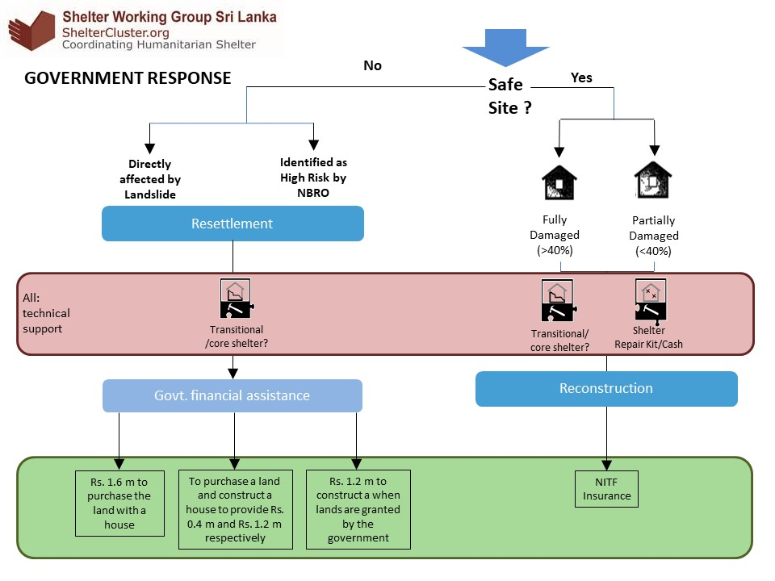

As part of the government response, NDRSC provided advance national insurance (NITF) payments of LKR 10,000 to affected households. A technical committee, consisting of a technical advisor, NDRSC delegate and the GN officer are conducting technical assessments of partially and fully damaged houses affected by the floods, to determine the eventual NITF insurance payment. In addition, NDRSC provided households in evacuation centres with a rental subsidy of LKR 7,500 per month for three months.



|  |
| --- |
| **IMPORTANT:** *Key principles for shelter response should reflect the importance of reaching all members of an affected community, especially the most vulnerable individuals. This may require consultation, for example with persons with disabilities, on how to adapt shelter and household items, shelter designs, or shelter delivery methods to be more suitable and inclusive.* |

# Emergency Shelter

Under Objective 1 of the Shelter Strategy, households that are able to remain in their current location, but whose house has been damaged, may be provided with a shelter repair kit. Following discussions with the partners of the Shelter Sector Working Group, the following standardized contents of a shelter repair kit was developed:

|  |  |  |  |  |  |  |
| --- | --- | --- | --- | --- | --- | --- |
| **SHELTER REPAIR KIT (Range: USD73-89)** | |  |  |  |  |  |
|  |  |  |  |  |  |  |
| **Priority** | **Items** | **Description** | **Unit** | **Qty** | **Rate** | **Amount (LKR)** |
| high | CGI (Galvanized Corrugated Iron) Sheets | 26G(0.4mm) thickness, size 10' x 2'8" | Nos | 10 | 460.00 | 4,600.00 |
| high | Mammoty/Hoe with handle | 10" x 8" (250mm x 200mm), Handle 3.5'-4' long with Dry, Smooth and flexible wood. | Nos | 1 | 1,650.00 | 1,650.00 |
| high | Hand saw | 40mm blade, Length 500mm + 50mm, Laminated carbon steel, 7 teeth per inch, | Nos | 1 | 790.00 | 790.00 |
| high | Crow bar | 1200mm (4') long, 16mm-25mm dia strong steel. | Nos | 1 | 650.00 | 650.00 |
| high | Claw hammer | 0.75 lb (300g-350g). Handle with Dry strong flexible wood | Nos | 1 | 500.00 | 500.00 |
| high | Mana' knife/ Machete | Curved blade, 55mm long with wood handle | Nos | 1 | 1,200.00 | 1,200.00 |
| high | Roofing Nails | 75mm long (3.0"), Umbrella type, Spiral roll or twisted shank, sealed umbrella type spring head, rubber washer 26mm dia, 2mm thickness | Kg | 0.5 | 280.00 | 140.00 |
| high | Nails | 75mm(3") for wood | Kg | 0.5 | 200.00 | 100.00 |
|  | Nails | 40mm(1.5") for wood | Kg | 0.5 | 200.00 | 100.00 |
| high | Shears | 260mm length, Straight for metal sheet | Nos | 1 | 380.00 | 380.00 |
|  | Rope | 12mm dia, 30m length, | m | 30 | 45.00 | 1,350.00 |
|  |  |  |  |  |  | **11,460.00** |
|  |  | In USD (1$=152.00) | | | | 73.90 |

# Household non-food items (NFIs)

Under Objective 2 of the Shelter Strategy, all households in need of general household items may be provided with Non-Food Items (NFI) kits. This section presents a list of the essential shelter- and household-related to be distributed as part of the emergency response operation, other standard NFI kits can be accessed through:

*IFRC Emergency Items Catalogue: http://procurement.ifrc.org/catalogue/*

|  |
| --- |
| **DISCLAIMER:** *Item specifications in this document are intended to support agreed minimum standards for the emergency response. They are NOT detailed enough to be used for procurement.* |

|  |  |  |  |  |  |
| --- | --- | --- | --- | --- | --- |
| **HH NFI - KIT (Range USD 50-56)** | |  |  |  |  |
|  |  |  |  |  |  |
| **Priority** | **Items** | **Specs** | **Qty** | **Rate** | **Amount (LKR)** |
|  | **Kitchen Utensils** |  |  |  |  |
| high | Cooking pot | Aluminium - 6Ltr | 1 | 400.00 | 400.00 |
| high | Sauce Pans | Aluminium with handles - 10",9" & 8" dia | 1 | 300.00 | 300.00 |
| high | Deep Plates | Stainless steel | 5 | 100.00 | 500.00 |
| high | Mugs with handles | Stainless steel - medium size | 5 | 50.00 | 250.00 |
| high | Curry Spoon | Stainless steel | 2 | 50.00 | 100.00 |
| high | Rice Spoon | Stainless steel | 2 | 50.00 | 100.00 |
| high | Kitchen knife | Stainless steel blade and wooden handle | 2 | 250.00 | 500.00 |
| high | Kerosene Oil Cooker / Stove |  | 1 | 1,500.00 | 1,500.00 |
| high | **Coconut Scraper** |  | 1 | 850.00 | 850.00 |
| **Lighting** | | |  |  | - |
| high | Solar Lamp | Rechargeable with solar light | 1 | 750.00 | 750.00 |
| high | Torch with batteries |  | 1 | 350.00 | 350.00 |
|  | **Beddings** |  |  |  | - |
| medium | Bed sheets | Cotton - double size | 2 | 600.00 | 1,200.00 |
| medium | Bed sheets | Cotton - single size | 2 | 450.00 | 900.00 |
| low | Pillow cases | Medium size | 4 | 150.00 | 600.00 |
| low | Curtain | 6' x 4' cloth material | 1 | 350 | 350.00 |
|  | Mosquito net |  | 2 |  |  |
|  |  |  |  |  | **8,650.00** |
|  |  | In USD (1$=152.00) | | | 56.91 |

NB: Note that one of the main challenges in using the kit approach is that procurement processes need to be well managed so that all items can be combined in the kits in a timely manner for distribution. If procurement is a challenge, the distribution of kits might be slowed down by missing items. This needs to be factored into programme design and implementation.

# Cash Response

Depending on context, regulations and market availability, emergency aid may be more effective, efficient and transparent, if provided in the form of cash distributions. Providing cash improves efficiency and cost-effectiveness by reducing the need for procurement, storage and transportation of goods. In addition, by improving people’s decision-making power it supports their dignity as well as local jobs, incomes and markets. Cash can be provided in different forms: through vouchers, cash-for-work, or unconditional grants.

Before deciding to use cash as assistance type, it is advisable to undertake an Emergency Market Mapping and Analysis (EMMA) assessment, to determine whether the market is strong enough and can provide all the products that people need. If the market is not strong enough and availability of products limited, agencies may start with NFI programming, and increase the cash component as markets develop and more items become available.

While insecurity may hamper cash payments if money is directly distributed to beneficiaries, in Sri Lanka most people have access to a bank account, which can be used for cash transfers. The private sector can be utilized to support distribution, increasing financial inclusion by linking people up with institutions and strengthening the local systems.

If providing cash-for-work, under the Sri Lanka intersectoral cash working group, organizations are requested to regularly check the minimum daily wage in the districts (Government rate) and to set criteria to standardize the amount (current standard is set at 70% of the existing minimum daily wage).

# Transitional/ Core shelter

Households that have lost their house, whose house is damaged beyond repair, and/or those that need to relocate, may be provided with a transitional shelter. Transitional shelter is an incremental process that shelters families after a conflict or disaster, and may start with the distribution of tarpaulins, tents, and the construction of houses with recovered materials. When providing a transitional shelter, agencies need to ensure that the shelter and/or the materials used for construction can be of use in the construction of a permanent house as much as possible.

National construction codes and local parameters for hazard-resistant design need to be considered first, to build and improve existing shelter construction techniques and designs to build back safer and increase communities’ resilience to future disasters.

## 6.1 Tents

Tents may be provided as emergency shelter, and as temporary solution in evacuation sites.

*Minimum tent standards*: http://itemscatalogue.redcross.int/overview.aspx?volume=1&groupcode=111&familycode=111001#1_111

*Use of family tents:* https://www.sheltercluster.org/sites/default/files/docs/Guide%20to%20the%20Use%20and%20Logistics%20of%20Family%20Tents.pdf

## 6.2 Transitional shelter

The design of a transitional shelter should include considerations regarding the terrain on which it is built. Within the working group consensus was reached that any transitional shelter provided needs to ensure that materials can be re-used, in addition, a technical consultation with the relevant authorities (DS, NBRO, etc.) is required. If a transitional shelter is built on land not (yet) safety approved by NBRO, the shelter needs to be transportable to a new location as well.

*IFRC transitional shelter designs:*

http://www.ifrc.org/PageFiles/95186/900300-Transitional%20Shelters-Eight%20designs-EN-LR.pdf

*IOM transitional shelter guidelines:*

https://www.iom.int/files/live/sites/iom/files/What-We-Do/docs/Transitional-Shelter-Guidelines.pdf

## 6.3 NBRO core house

One method of providing households with a temporary shelter while contributing to a permanent solution is the construction of the ‘core house’ according to NBRO guidelines, which provides households with funding to construct a house in separate phases, depending on the approval of safety of foundation and construction by NBRO trained engineers (figure 5 – phase 1 of core house).

Figure 5: NBRO core house model – phase 1

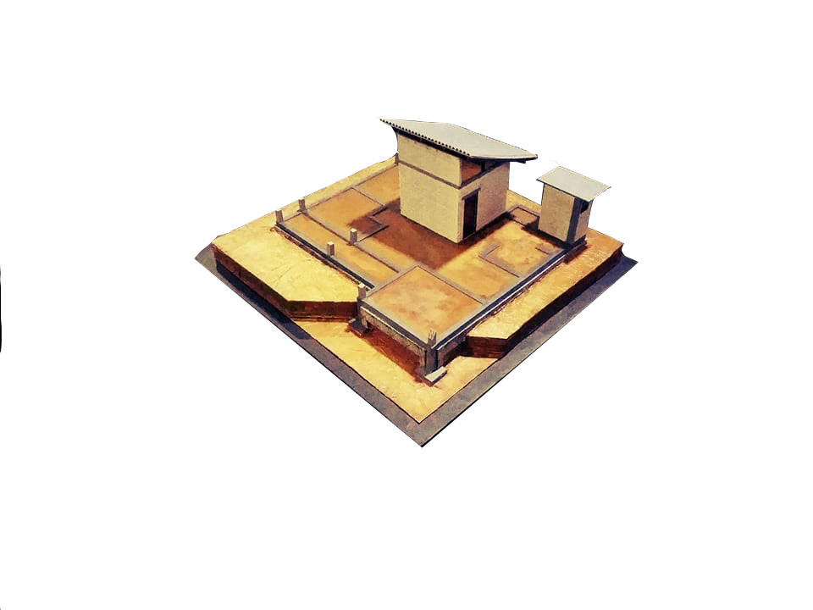

To minimize the time families have to spend in temporary evacuation centres, NBRO proposes the following schedule and instalments for the development of a 'core house'. Families may also opt for construction of the entire core house, moving on from the 'one room and toilet' option.

NBRO proposed core house:

*Two stages*

- Stage 1: Construction of one room with toilet

- Stage 2: Completion of core house

*Four instalments – total LKR 1,200,000 (USD 7,850)*

1. Land preparation, excavation and completion of foundation – 200,000

2. Completion of one room and toilet – 300,000

3. Construction of walls of rest of core house and completion of roof – 400,000

4. Completion of core house: doors, windows, plastering, finishing and painting, supply of water and electricity – 300,000

Note:

Minimum floor area of 650 sq. ft.

Resilient foundation and a superstructure (As directed by NBRO)

Two bedrooms

A kitchen

A permanent roof and

A water seal toilet and the septic tank

Figur 6: NBRO core house cross section and floor plan

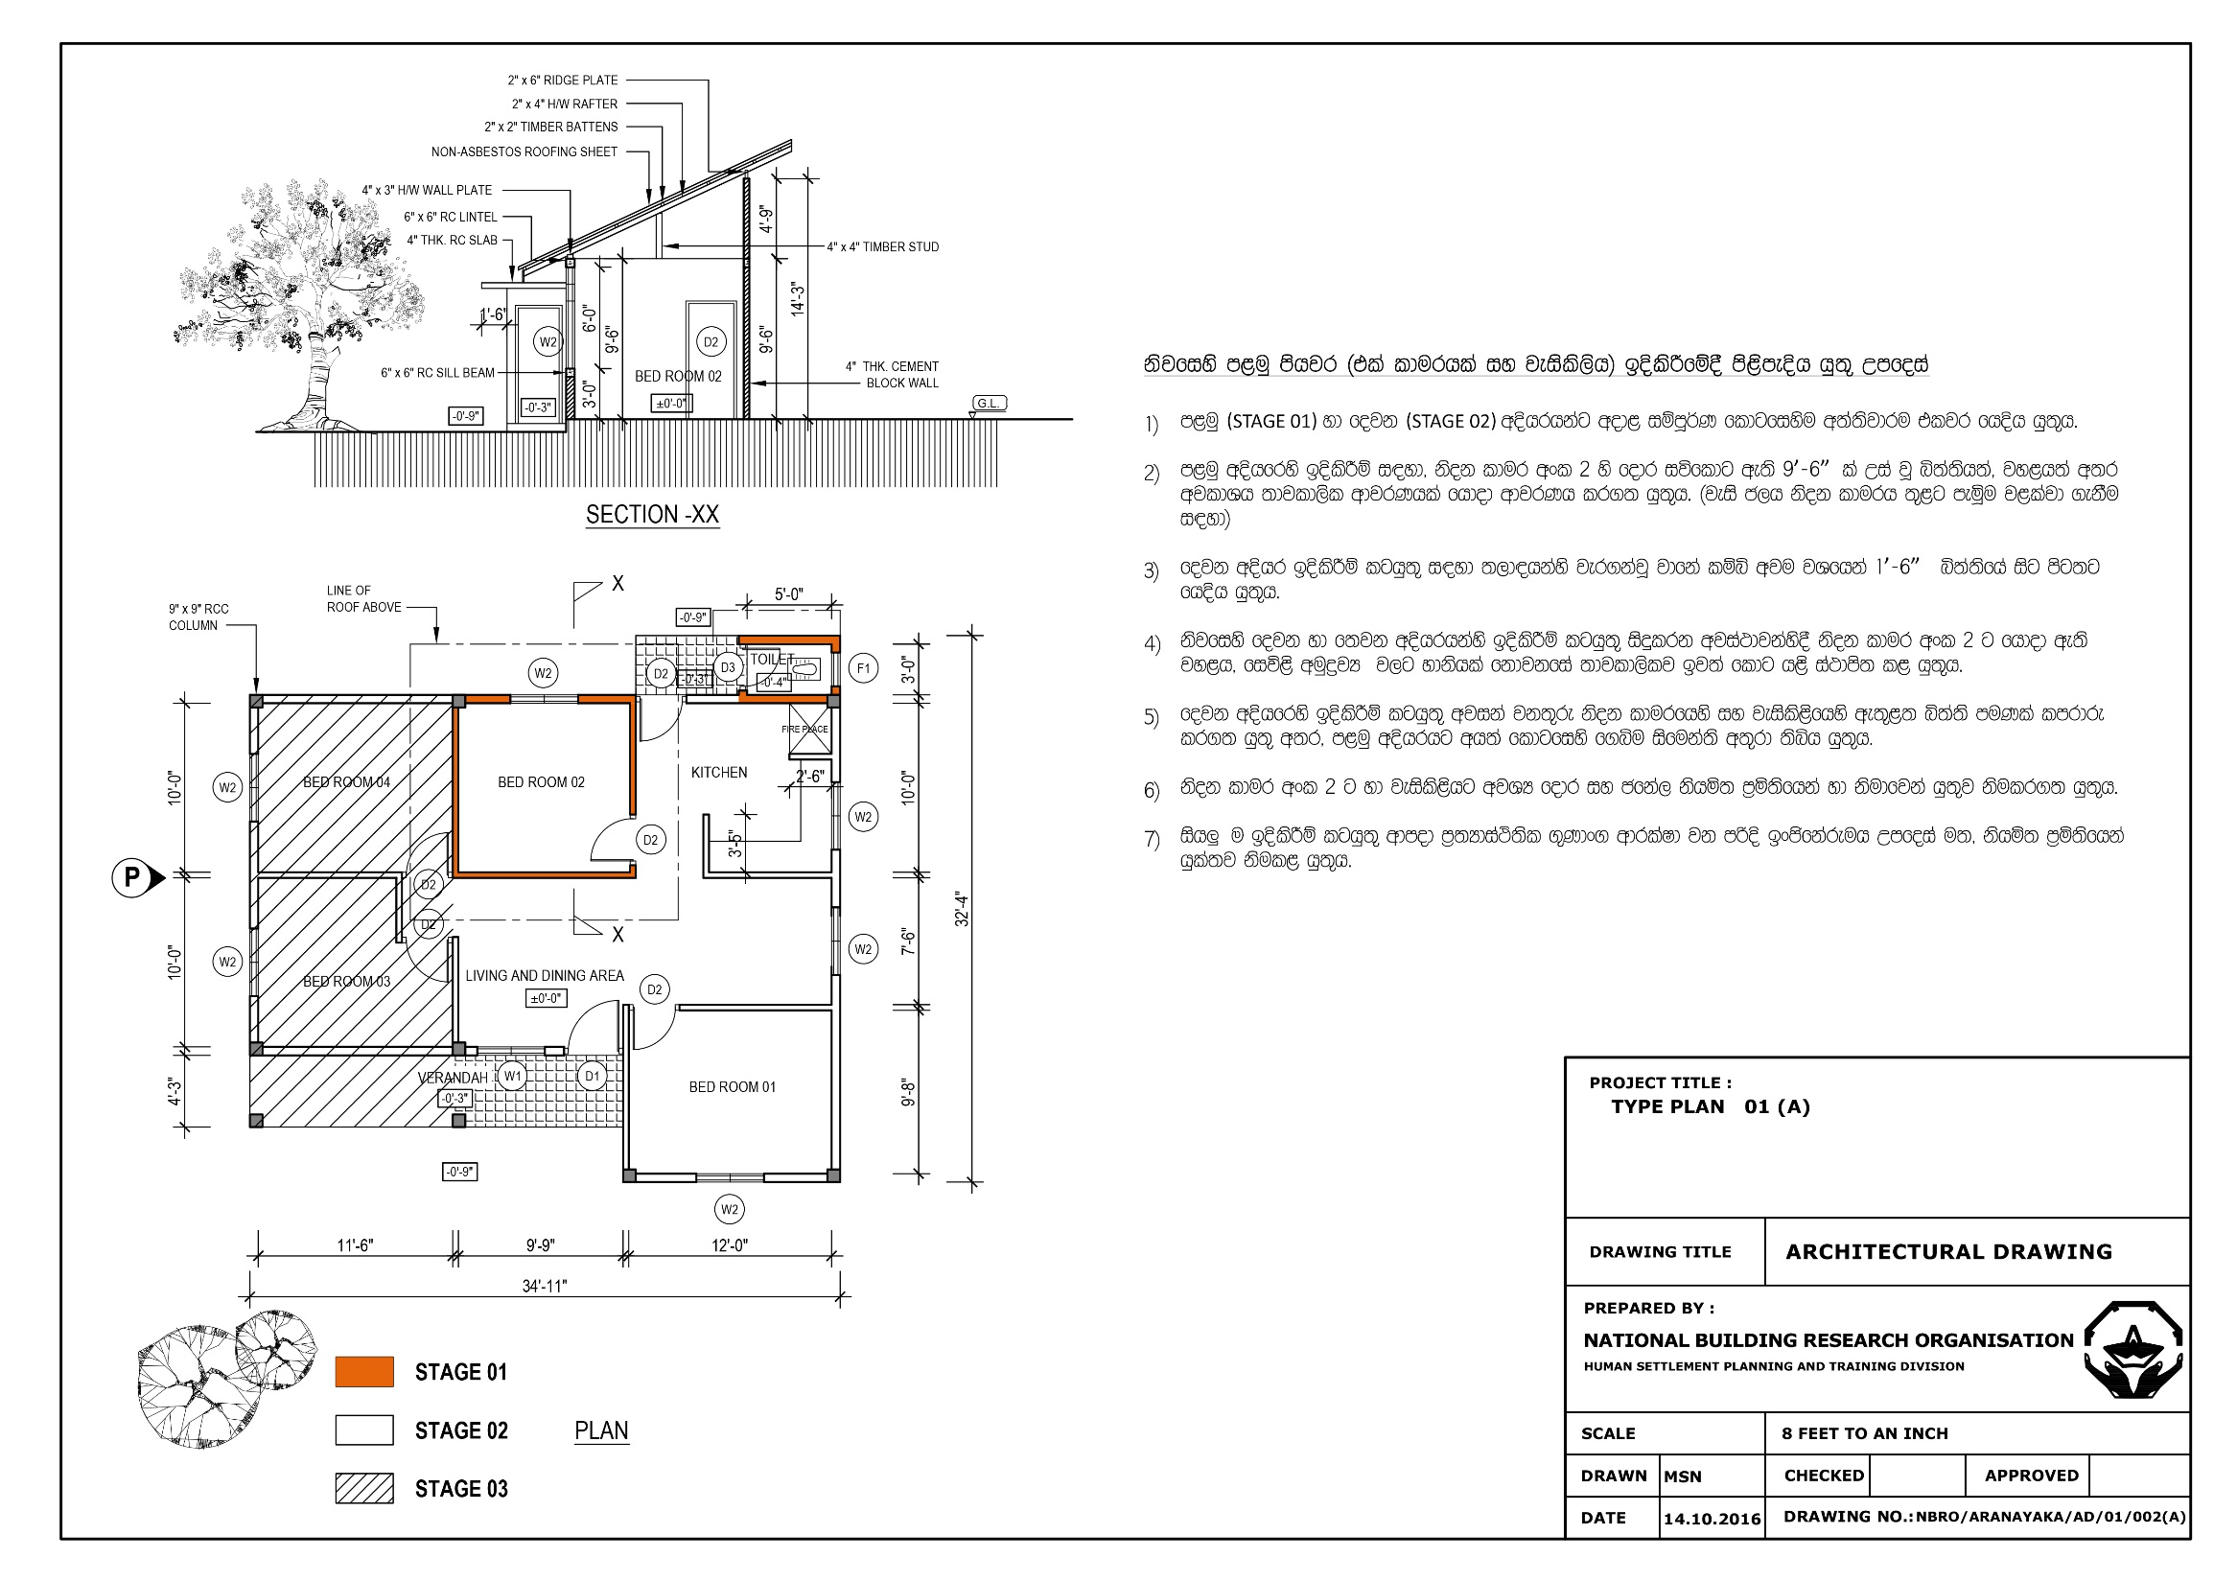

## 6.4 Construction codes & consensus standards

The following section gives the local building codes and standards applicable in Sri Lanka, standard construction material guidance can be found in Annex 4. There are multiple ministries and development authorities involved in development of planning and building codes, laws and regulations, a few of which are reflected in below table – agencies need to confirm guidelines represent the latest standards in the targeted region.

|  |  |  |
| --- | --- | --- |
| **Type of code/standard** | **Name** | **Link** |
| Ministry of Housing and Construction | National Housing Development Authority Acts | http://houseconmin.gov.lk/regulation-and-polices-of-ministry/ |
|  | National Housing Policy (English) | https://drive.google.com/file/d/0B6o-6gqv4JNBRGFfRE1IWXRvXzQ/view |
| National Physical Planning Department (NPPD) | National Physical Planning Policy and Plan (2010) | http://www.preventionweb.net/files/15417_nationalphysicalplanningpolicyplan.pdf |
| Urban Development Authority (UDA) | Acts and Regulations | http://www.uda.gov.lk/act-regulations.php |
|  | Housing and Town Improvement Ordinance (1980) | http://srilankalaw.lk/Volume-IV/housing-and-town-improvement-ordinance.html |
| Disaster Management Centre (DMC) | Mainstreaming DRR into Housing Sector in Sri Lanka (includes an overview of codes) | http://www.dmc.gov.lk/Publications/housing_SL.pdf |
| Coastal development | Coast Conservation Act No. 57 (1981) | http://www.coastal.gov.lk/downloads/pdf/Permit%20Guidline.pdf |
| Overall building code | NBRO guidelines on hazard resistant construction | https://www.sheltercluster.org/sites/default/files/docs/resilient_manual_0.pdf |
| Gravity loads |  | https://archive.org/stream/en.1991.1.1.2002 |
| Landslides | NBRO: Landslide Hazard Zonation Mapping |  |
| Wind code | [status Sri Lankan National Annex to Eurocode 1]  [CP 3 Chapter V: 1972, Code of Basic data for the design of buildings chapter V. Loading, Part 2 Wind Loads, British Standard Institution, London]  [Australian standard AS/NZS 1170.2:2002] | http://www.wind.arch.t-kougei.ac.jp/APECWW/Report/2012/Sri.pdf  https://www.saiglobal.com/PDFTemp/Previews/OSH/as/as1000/1100/1170.2-2002(+A1).pdf |
| Earthquake code | [Euro Code 8 (EN 1998-1: 2004)] | ftp://ftp.norsar.no/pub/outgoing/conrad/cuba/EC8.en.1998.1.2004.pdf |
| Fire code |  |  |
| Material codes |  | *E.g. timber, concrete, steel, masonry, reinforcing steel* |
| Geotechnical codes/ ground conditions |  | [NBRO Geotechnical Engineering Division] |

# Disaster Risk Reduction / Community Awareness

To promote ‘build back better’, the Shelter Sector Working Group developed technical Information, Education and Communication (IEC) brochures and flashcards based on NBRO construction guidelines to support home-owner driven recovery and resilient construction. In addition, the working group develops IEC posters for distribution in evacuation centres/ safe sites to increase awareness of location safety, environmental hazards and other risks.

A resilient community is one that can prepare for, adapt to and absorb shocks while retaining its basic assets, structure and functions. Resilience measures should incorporate DRR, climate change adaptation and poverty reduction, whereas community-based solutions increase the sense of ownership. The security of the existing household asset base has a direct impact on its ability to absorb the shocks and stresses associated with disasters and displacement, therefore livelihood protection and rehabilitation is an important aspect of resilience building.

More general standard IEC material is developed by DMC and available on the Sri Lanka Shelter Working Group website for printing and distribution to increase community DRR awareness and/or support training. These materials are ideally distributed during the delivery of response.

All materials are attached for printing purposes in Annex 6.

# ANNEXES

## ANNEX 01: Background Information

|  |  |  |  |
| --- | --- | --- | --- |
| **OVERVIEW** | | **UNDERSTANDING** | **PARAMETERS** |
| **CONTEXT** | * Climate/topography /altitude (maps) * Urban/peri-urban/rural * Housing typologies * Land ownership, tenure, customary and/or statutory legal system * Local regulations and building codes, * Political context and dynamics * Social and cultural | * Climate variations between summer and winter, rainy seasons may have a strong impact * Density, logistics, network, * Timber, bamboo, masonry, single storey, apartment blocks, etc. * current usage of regulations | * Appropriate location, minimum ventilation, winterisation, etc. * Appropriate size and type of design * Appropriate materials to use * Arrangements (rental) with landowners * Application of local regulation might vary depending on the stage of the response and the intervention |
| **HAZARD** | * Disasters (cyclones, typhoons, hurricanes), Tornadoes, Tsunami, Earthquakes, Floods, Landslides, Fires, Volcanoes, Epidemic, Wildfire, Drought * Conflict | * Keep in mind secondary crisis or combination of hazards | Seasonal/ hazard overviews |
| **COORDINATION** | * Type and scale of emergency (3/4W) * Resources: Damages, Funding, Politics, Security, protection concerns, accessibility to functioning markets. |  |  |

## ANNEX 02: Definitions of NFI items

|  |
| --- |
| *Please note that the specifications below are not intended for procurement purposes. Instead they are intended to help define the items. For procurement specifications we suggest http://procurement.ifrc.org/catalogue or other agency catalogues as a starting point. For shelter repair kits, see also Chapter 3.* |

|  |  |  |
| --- | --- | --- |
| **QUANTITY** | **SPECIFICATION** | **LINKS** |
| **Bedding and Mats:** | | |
| Depending on needs | * Bed camp foldable * Mattress (foam) and bed sheet set (cotton) * Mat (foam) and bed sheet set (cotton) * Pillow and pillow cases (cotton) * Sleeping mat (plastic or fibre) * Insulating floor mat (aluminized, fleece covered) | http://procurement.ifrc.org/catalogue/overview.aspx?volume=1&groupcode=108&familycode=108004 |
| **Blankets and Quilts:** | | |
| The recommendation is 5 blankets (1.5mx2m) for the average family size. | * Cotton blanket or Kanga (100% cotton, 80% cotton) for hot and humid climates | http://procurement.ifrc.org/catalogue/overview.aspx?volume=1&groupcode=108&familycode=108004 |
| **Cleaning items:**  Items to be provided to families to clean-up their property and surrounding after a crisis: | | |
| Refer to IFRC [Emergency Items Catalogue](http://procurement.ifrc.org/catalogue/) for further details | **Items contained in a cleaning kit**   * Push broom type (45cm) * Scrubbing broom type with brush (30cm width block, including head and stick) * Scrubbing brush * Fringe wet mop for washing floor (with mop head and stick) * Floor blade (with mop head and stick) * Floor cloth * Dust pan * Detergent, disinfectant, cleaning liquid (multi-purpose for house and for dishes) * Garbage and rubbish bags * Sponge | <http://procurement.ifrc.org/catalogue/detail.aspx?volume=1&groupcode=111&familycode=111001&categorycode=CLEA&productcode=KRELCLEA01> |
| **Fixing tools:**  Essential to most shelter activities, to connect construction materials and fix tarpaulins. Below is a list of commonly used fixings (this is not an exhaustive list)   * **Rope** - common to connect plastic sheeting. * **Wire** - often used for bracing. * **Nails -** different sizes and types of nails are recommended. * **Hurricane Straps -** frequently used to reinforce timber structures. | | |
|  | * **Rope** For fixing plastic sheeting, black rope 8mm to 14mm diameter is preferred, as black is more resistant to UV degradation. * **Wire:** galvanised tie wire, diameter 1.5mm in 25mm roll * **Nails:** 75mm long (3.0"), Umbrella type, Spiral roll or twisted shank, sealed umbrella type spring head, rubber washer 26mm dia, 2mm thickness * **Hurricane straps**: [e.g. galvanized, perforated, 32mm, coil 30m] | http://procurement.ifrc.org/catalogue/detail.aspx?volume=1&groupcode=111&familycode=111001&categorycode=CARP&productcode=KRELCARP01 |
| **Kitchen set:**  The number of utensils generally covers for a minimum of 5 people. | | |
| To agree: 1 set per household of 5 | Suggested cooking set: Bowl 1L x3; chopsticks, spoon, plat, cup x5; wok 7L; frying pan (used as lid for the 7L cooking pot); kitchen knife (stainless steel); wooden spoon; cooking pots 7L; sourcing pad. | <http://procurement.ifrc.org/catalogue/overview.aspx?volume=1&groupcode=108&familycode=108001> |
| **Mosquito net:**  Mosquito nets should conform to WHOPES testing. Following WHOPES recommendation, only Long Lasting Insecticidal Nets (LLIN's) that require no further treatment during their expected life span (of average 3 to 5 years according the use, type and fabric origin) should be purchased. This might be adapted to the local market and availability of stocks. | | |
| Suggested number 2 per household | Mosquito nets for:   * 2x Double bed (rectangular) | <http://www.who.int/whopes/Long_lasting_insecticidal_nets_Jul_2012.pdf>  <http://www.who.int/entity/malaria/publications/atoz/itnspospaperfinal.pdf> |
| **Tarpaulins and Plastic Sheeting:**  Tarpaulins and plastic sheeting are among the most widely distributed NFIs and are often used to provide emergency shelter until more durable solutions are found. They are not a building solution on their own and need to be combined with materials to form a structure and with fixings to securely attach it.  If procurement is done locally, clear specification should be issued and it should be field-tested. They could be distributed as:   * **Sheets** of 4m x 5m-4m x 6m-4m x 7m tarpaulins for individual shelter purpose * **Rolls** of 4m x 60m for community purpose. | | |
| 3 tarpaulins for a family of 5. | **Weight:** 190g/m2 ± 20g under ISO 3801, equivalent to 170g/m2 minimum to 210g/m2 (add 10% additional weight for the reinforcement bands).  **Core material:** woven fabric High-Density Polyethylene (HDPE) laminated between two layers of Low-Density Polyethylene (LDPE).  **Lifetime** of approximately 2 years if of suitable quality.  **Reinforcement:** 2 options: eyelets or reinforcement bands: | For uses of Plastic Sheeting see: <http://www.ifrc.org/PageFiles/95534/D.03.a.01.Plastic%20Sheeting_Englis.pdf>  For examples of full specifications and testing sampling methods, see: IFRC/ICRC [Emergency Items Catalogue](http://procurement.ifrc.org/catalogue/) |
| **Tents:**  A tent is not a long-term housing solution and is meant for emergencies. It should have a minimum of one-year lifespan, irrespective of climate. All tents should conform to the recommended minimum-standard living area for hot and temperate climates (3.5m² per person) and should be made of waterproof canvas, and must have a strong supporting frame.  Tents specialised for humanitarian relief have been developed over many years by the larger organisations. Purchasing suitable tents requires establishing clear specifications and understandings with manufacturers. | | |
|  | **Specification:** The recommended tent specifications are those used by IFRC, UNHCR and ICRC. Both standard and frame versions are available:  **Size:** minimum of 16m2usable covered area.  **Design:** Double fly is required to provide a ventilated air gap for enhanced thermal performance and improved water resistance. A separate flysheet, usually made from canvas, fits over the inner tent. The poles form the vertical supports and the ridge beam. This gives suitable structural resistance to high winds. The tent must have rot proof mud flaps of suitable quality and length to allow the tent to be dug into the ground.  Optional: Tent divider - Partition for privacy is recommended to improve protection. | <http://procurement.ifrc.org/catalogue/upload/products_data/files/HSHETENT01.pdf>  <http://www.sheltercentre.org/sites/default/files/UNOCHA_tents.pdf> |
| **Tools:**  Tools are an essential part of many shelter interventions, to allow for self-recovery. | | |
|  | Below is a list of commonly used tools (this is not an exhaustive list)   * **Hammer (with nail claw)** * **Hand saw,** various types of hand saw might be provided, some specific to wood, other multipurpose. * **Shovel,** useful tool and commonly used when building foundations. * **Knife cutter** * **For brick construction** (including mud bricks): Storage vessels (buckets/bags), mixer, etc. | Refer to IFRC tool kits book  <http://www.ifrc.org/PageFiles/95526/publications/D.03.a.07.%20IFRC%20shelter-kit-guidelines-EN-LR.pdf>  Refer to IFRC Emergency Items Catalogue: <http://procurement.ifrc.org/catalogue/index.aspx> |

## ANNEX 03: NBRO Policy Framework

http://www.nbro.gov.lk/images/2016_pdf/publications/rev.pdf

## ANNEX 04: Descriptions of construction materials

|  |
| --- |
| **NOTE:** *The below list contains examples, and is not exhaustive. Use it as a starting point, or consult the publication “Selecting NFIs for Shelter” (IASC/Emergency Shelter Cluster, 2008), which also contains a list of shelter NFIs and references to literature that contains recommendations or specifications for each item category (Chapter 5.3, p. 51).* |

|  |  |  |
| --- | --- | --- |
| **QUANTITY** | **SPECIFICATION** | **LINKS** |
| **Bamboo:**  Bamboo is the stem of a fast-growing grass, reproducing through its roots. The high speed of its re-growth is attracting more interest in its use as a construction material. | | |
|  | The Shelter Sector Working Group recommends using bamboo for structural framing, walling, roofing. | <http://humanitarianbamboo.org/>  <http://humanitarianlibrary.org/sites/default/files/2014/02/Bamboo%20fact%20sheet%202.pdf> |
| **Bricks, Blocks and Binders:**  Concrete hollow blocks (CHB), solid blocks and bricks are commonly used materials: | | |
|  | Forspecification refer to national building code and other relevant standards.  Include: concrete: blocks: hollow or in one piece, adobe bricks, burnt bricks, stabilised bricks and compressed blocks (stabilised or non stabilised.) | Refer to: <http://www.sheltercentre.org/sites/default/files/Selecting%20NFIs%20for%20Shelter_0.pdf> section 5.2.7 |
| **CGI sheet (Corrugated Galvanised Iron Sheet):**  Iron sheets coated with zinc or with aluminium/zinc galvanisation, used for roofing and roof-repairs. | | |
|  | **Specification:** Thickness, and coating is an important factor for strength and durability.  Minimum recommended thickness: Gauge 26 equivalent to 0.457mm  **Safety** – Handling CGI on site: ensure that handling staffs are equipped with gloves and sturdy boots to prevent injury, and that a first aid package is available at loading and off-loading locations. | Refer to IFRC Emergency Items Catalogue: <http://procurement.ifrc.org/catalogue/index.aspx> |
| **Concrete:**  Concrete is a [composite material](http://en.wikipedia.org/wiki/Composite_material) composed mainly of [water](http://en.wikipedia.org/wiki/Water), [aggregate](http://en.wikipedia.org/wiki/Construction_aggregate), and [cement](http://en.wikipedia.org/wiki/Cement). Often, additives and reinforcements are included in the mixture to achieve the desired physical properties of the finished material. When these ingredients are mixed together, they form a fluid mass that is easily moulded into shape. Over time, the cement forms a hard matrix which binds the rest of the ingredients together into a durable stone-like material with many uses. Once mixed together concrete has the advantage of having a high compressive strength (it is hard to crush) but is still quite weak in tension (is easily pulled apart). Commonly steel rods are added to overcome the tensile weakness making it both hard to crush and hard to pull apart, hence becoming a very strong composite building material. | | |
| XX sacks per household. | **For** specification on the right mixing proportion for concrete, refer to national building codes. | Binders: <http://www.sheltercentre.org/sites/default/files/Selecting%20NFIs%20for%20Shelter_0.pdf> 5.2.7 |
| **Timber:**  When building with timber, agencies should ensure they are using the appropriate materials with the right grade and classification, designed and built in safely and appropriately, recycle whenever possible, and source legally and sustainably.   * **Coconut wood:** Coconut wood has unique properties as the density of the wood varies, with the centre being the softest and non-structural, and the outer section being the denser and strongest. | | |
|  | **General description:** Protection against termites is extremely important in the use of wood for construction, it can be achieved with impregnation of waste engine oil mixed with diesel or insecticides.  **For an example of a specification table, see *“****Timber - A guide to the planning, use, procurement and logistics of timber as a construction material in humanitarian relief,” p. 49-50.* | <http://www.ifrc.org/PageFiles/95530/D.03.c.01.%20Timber%20Guidelines-EN.pdf>  IFRC/ICRC Emergency Items Catalogue: http://procurement.ifrc.org/catalogue/detail.aspx?volume=1&groupcode=111&familycode=111003&categorycode=WOOB&productcode=EBUIWOOB  Coconut Palm Stem Processing Technical Handbook, FAO: http://www.fao.org/docrep/009/ag335e/ag335e00.HTM |

## ANNEX 05: Template design brief for shelters

|  |  |  |
| --- | --- | --- |
| **Performance standards and indicators for post disaster shelters** | | |
| *Indicators* | *Standard* | *Remarks* |
| ***Key data*** | | |
| *Life span* | Materials and shelter construction to allow for more than 12 months use. Materials should allow for easy maintenance and upgrade. | Suggested life span:  Temporary: min. 1 year Transitional: min. 3-5 years Core: min. 5-10 years |
| *Cost* | US$1500 including transport and labour, excluding taxes and project management costs. For one storey shelter, assuming additional input of material and labour from home owners. | Consider supplying only some of the materials when existing materials remain.  Cost may be adjusted upwards due to market fluctuations. |
| *Covered living space* | Provide a target of 300ft2 floor space with 600ft2 as a maximum.  In exceptional cases, a minimum of 200ft2 may be considered for instances where no other space is available, and with a clear justification. | Assuming average of 4.5 persons per family. See Sphere. |
| *Head height* | A minimum of 2.5m from the floor to the eaves. |  |
| ***Hazard resistant construction*** | | |
| *Rains and*  *Floods* | The roof should protect the interior and walling materials from rain.  Foundations have sufficient strength and height to withstand flooding of site. | Ensure that any roof overhang is not so large as to increase the hazard from strong winds |
| *Wind and storms* | Foundations must secure the shelter to the ground in strong winds.  The roof must be fixed securely to be resistant to storms and must be designed with adequate strength for proposed roofing material.  Design structures so that structural members and joints take the loads rather than the fixings.  Metal strapping is strongly advised to protect against high winds. | A pitch of 300-450 for 2-pitched roofs is optimum to resist strong winds.  Wide roof spans are to be avoided as they weaken the structure. |
| ***Design principles*** | | |
| *Suitable for relocation* | Transitional shelter and some temporary shelters: can be relocated by the occupants.  All shelters: Where possible, materials should be re-usable. | The shelters may later be used as kitchens, verandas, or shops. |
| *Capacity to extend* | The shelter should be built so that occupants can easily extend it with their own resources. | Core shelter can be expanded and/or upgraded to permanent.  Transitional shelter materials can be re-used. |
| *Hazard resistant Learning* | Shelters should provide practical learning examples of principles of good construction (e.g. openings such as doors should be away from the corners of the structure). | To promote good earthquake, hurricane and flood resistance practice. |
| *Ventilation and thermal comfort* | Where possible, promote openings on 2 sides of the shelter to allow for cross ventilation  Allow for adequate ventilation and design to minimise internal temperatures. | Openings shouldn’t affect structural integrity of the shelter.  Take in consideration possible future extension or re-use of the unit/shelter. |
| *Privacy* | The design should allow the addition of at least one internal division for privacy.  The shelter should provide a flexible space. | Internal divisions should not go as high as the roof as this will reduce ventilation. |
| *Culturally appropriate* | Shelter layouts, materials and construction techniques are familiar or easy to understand by the beneficiaries. |  |
| *Access* | Shelters should take into account access and habitation/use by persons with reduced mobility. |  |
| ***Site and services*** | | |
| *Tenure* | Legal aspects of the site or plot should be resolved. | Take into account different forms of tenure security, including ownership, tenancy and other arrangements. |
| *Location* | In principle, the location of the shelter should support the choice made by the shelter owners themselves. Wherever possible, shelter should be constructed at, or near to the existing homestead, without inhibiting permanent housing reconstruction.  Shelters should not be built next to dangerous buildings or structures, on land liable to flood, or in locations that expose the occupants to other hazards.  Shelters should be built in locations that help occupants to maintain access to livelihoods, basic social services/community infrastructure (health, education, commercial) as well as electricity and telephone. |  |
| *Plot preparation* | Sites need to be cleared of any physical dangers. |  |
| *Water and*  *Sanitation* | Adequate water supply and sanitation facilities.  Construction must be coordinated with WASH.  Adequate site drainage is provided to minimise the risk of flooding. Individual Shelters must be connected to site drainage solution. |  |

## ANNEX 06: Information, Communication and Education (IEC) material

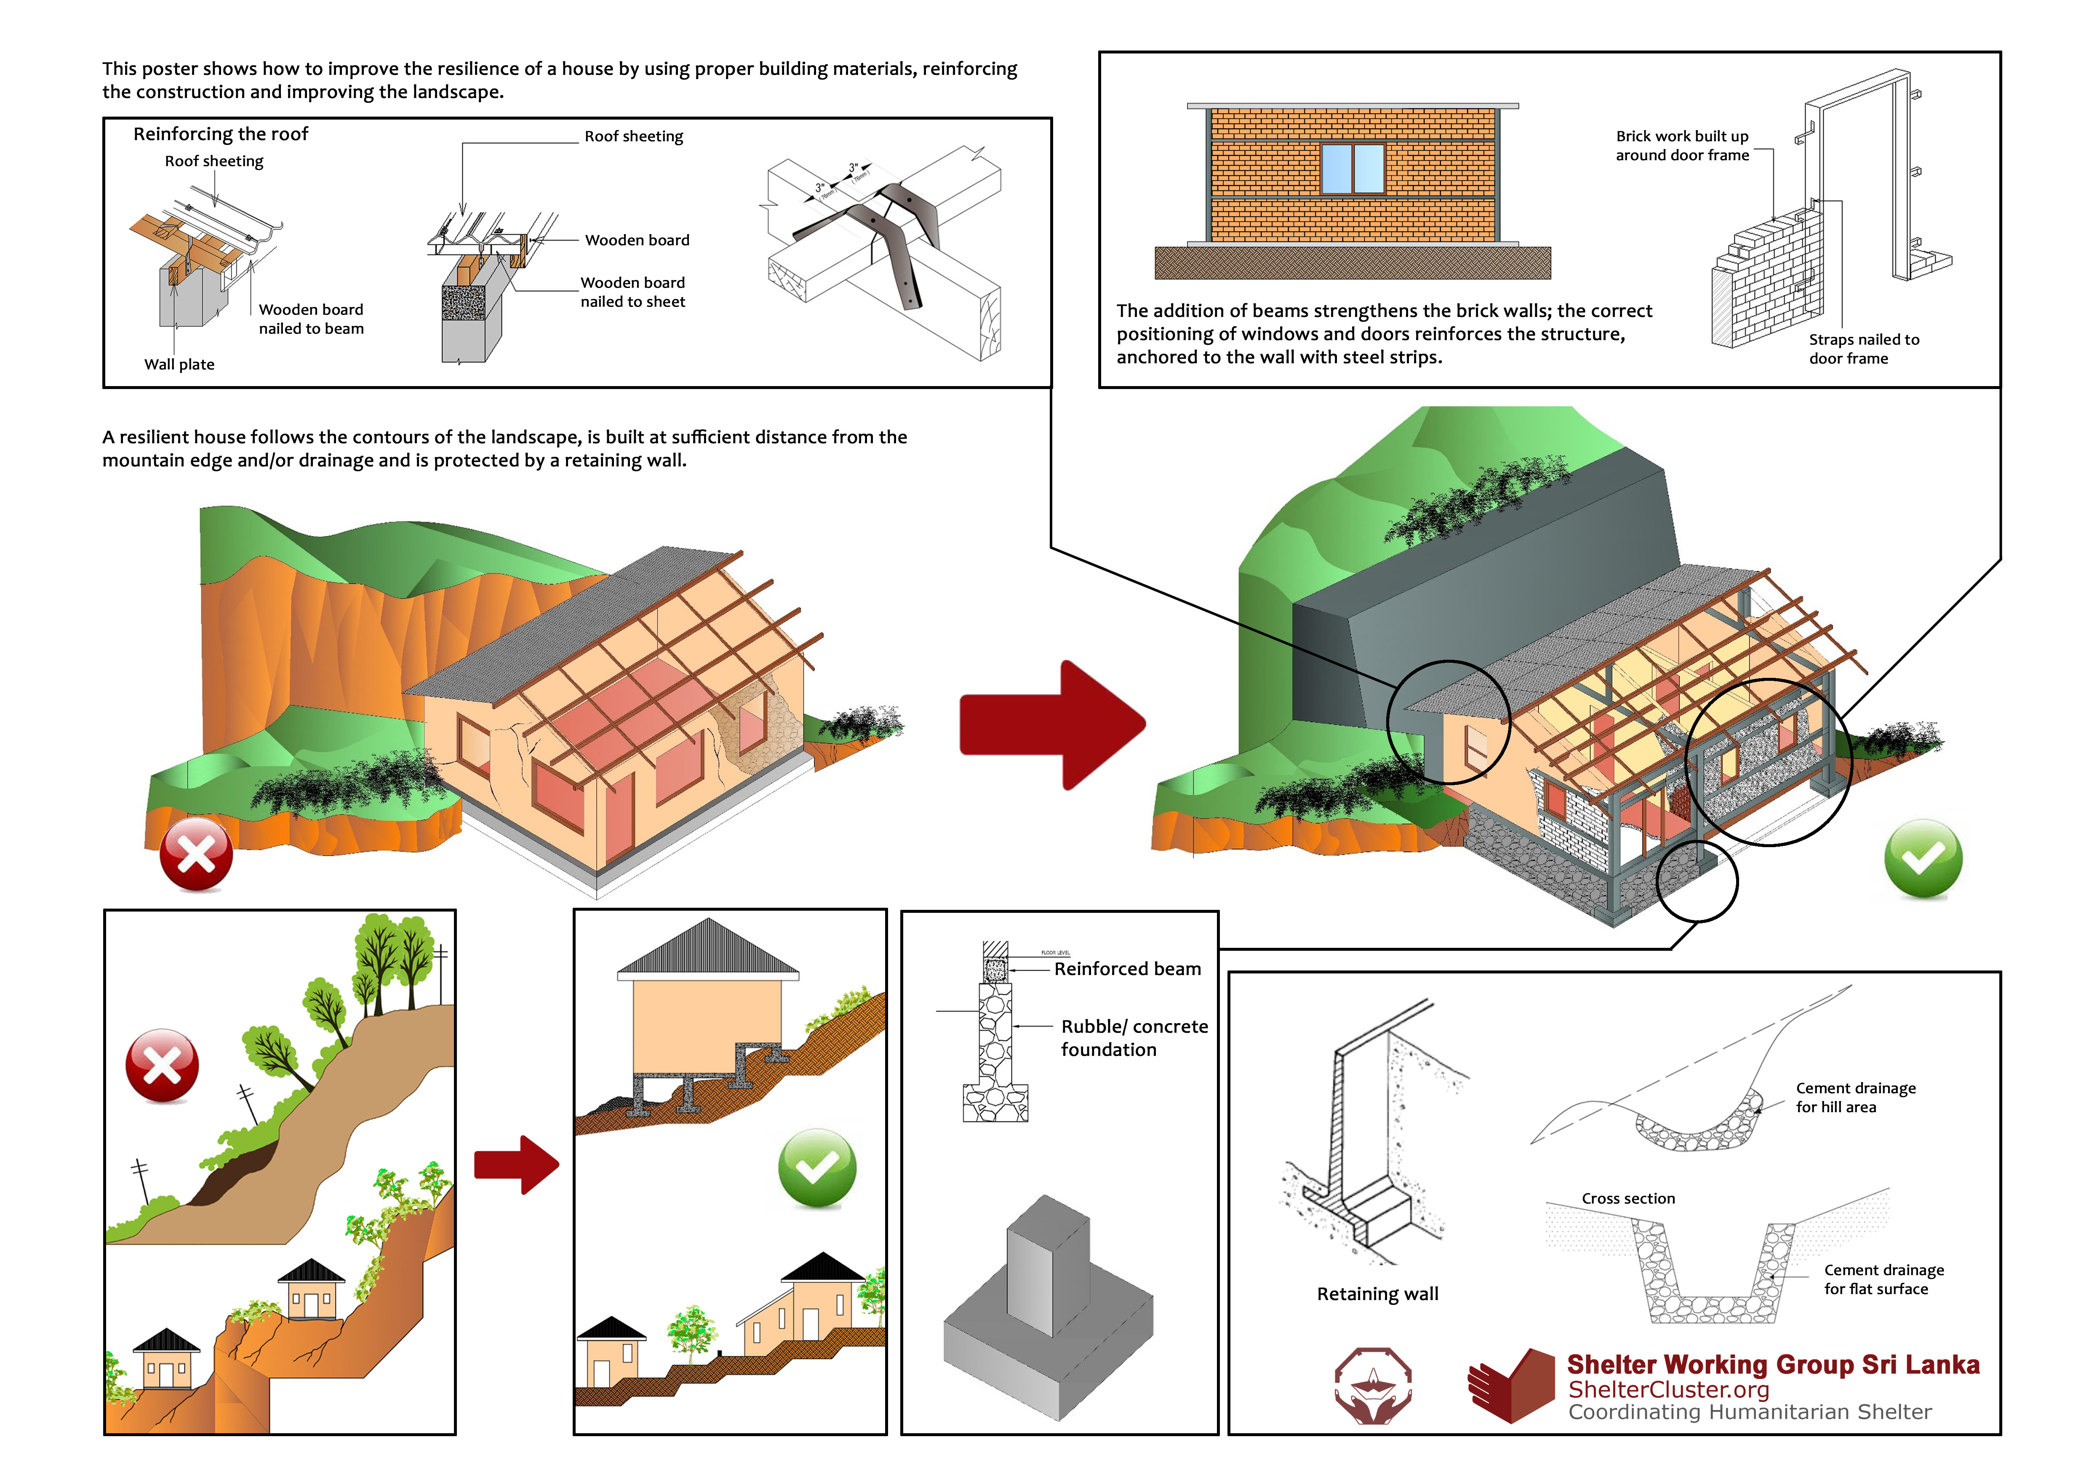

1. National Disaster Management Coordinating Committee (NDMCC) represents the globally promoted National Platform for Disaster Risk Reduction

   http://www.unisdr.org/files/601_engguidelinesnpdrr.pdf
2. NRC, 2015, *Community Resilience and Disaster-Related Displacement in South Asia*, https://goo.gl/gYgHbS