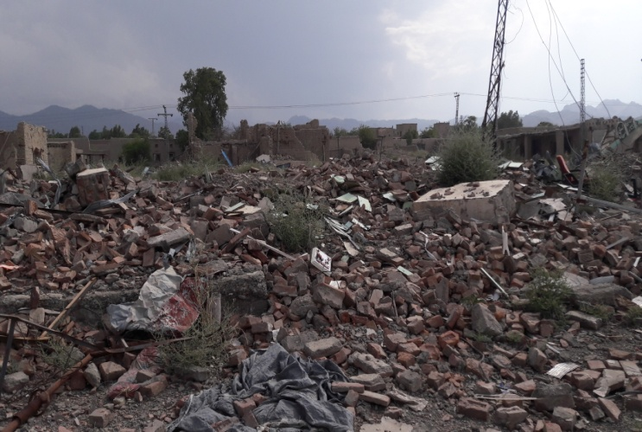****

Completetly damaged Degan Bazar at Datta Khel

**INTER-CLUSTER ASSESSMENT MISSION**

**TO NORTH WAZIRISTAN AGENCY**

**26-28 AUGUST, 2016**

**EXECUTIVE SUMMARY**:

**Key Findings and Recommendations:**

Due to the un-announced curfew on 26th and routine curfew on 28 August 2016 in the return areas, the mission managed to observe only 14 villages of Mirali, Miranshah, Ghulam Khan and Datta Khel tehsil from the road side. Overall, the security situation was perceived to be good as the entire recently de-notified areas was under the military control. The team noted the ongoing rehabilitation work on infrastructure. Main access roads across the de-notified parts (except at Datta Khel tehsil) are carpeted and open for use. Level 3 (demining) for most of the visited newly de-notified villages were in-progress, and as such limited the teams’ movement to the villages. As per information shared by the Political Agent (PA) Administration and Military / Para-Military representatives, most of the houses are considered to be in habitable condition. In addition, the officials also indicated that rehabilitation and construction of Tehsil Head Quarter Hospitals, BHUs, Schools, Water Supply Schemes, Electricity, and Solarization of most tube wells and provision of water collection points for drinking and household purposes were being undertaken. The Pakistan Army was providing water through tankering in areas where solar pumps had not been installed.

Recommended priority actions include:

* Cash for Work, for the rehabilitation of water/ irrigation channels and link road.
* Provision of livelihood support to create short term employment through conditional assistance of food for work and food for training.
* Establish temporary Learning centers.
* Repair and renovation of schools and health facilities.
* Establish mental health rehabilitation centers and provision of counseling services.
* Agriculture inputs, irrigation system and lands rehabilitation, livestock and poultry inputs and restocking in Mira Ali and Datta Khel, while only livestock and poultry in Miranshah and Ghulam Khan.
* Core Relief Items Kits and Conditional Cash grant provided to the returnees for the repair of houses.
* Establish Vocational training centers as a special support for the persons with specific needs.
* Initiation of Community based management of acute malnutrition program.
* Provision of household water storage containers including small water tanks, buckets and jerry cans on need basis.
* Basic WASH facilities needs to be rehabilitated in schools/health centers.

**Background:**

North Waziristan Agency (NWA) is the second largest Agency in Federally Administered Tribal Areas (FATA) with it’s headquarter at Miranshah. It is bounded on the north by Afghanistan, Kurram Agency and Hangu District, on the east by FR Bannu & Karak, and, Bannu district; on the south by South Waziristan Agency, and on the west also by Afghanistan. NWA border Afghanistan’s Paktika and Khost provinces. Chief tribes in NWA are the Utmanzai Wazirs and Dawars. There are also small tribes like Gurbaz, Kharsins, Saidgis and Malakshi Mahsuds. Subsequent to the launching of military *Operation Zarb e Azb* by the Pakistan Armed Forces on 15 June 2014 the entire Agency was notified as conflict zone and the inhabitants of NWA moved towards the neighboring districts of Bannu, Lakki, D I Khan, etc. In addition considerable portion of population moved to the adjacent provinces of Afghanistan. As per the UNHCR’s IDPs factsheet of 16 March 2015 a total of 102,424 families have been verified by NADRA and registered as IDPs. Following the steady achievement of the aforementioned military operation and the gradual de-notification the return was initiated on 31 March 2016. Till 30 August 2016 approximately 53000 families are returned.

In response to the decision taken at Return Task Force Meeting held Aug 16, 2016, Inter-Cluster Assessment Mission was initiated on 26-28 August 2016 to assess the viability for returns in the newly de-notified areas of NWA. Under the plan, approximately 6,900 families to 69 villages in 4 tehsils of NWA (Mir Ali, Miranshah, Ghulam Khan and Datta Khel) would be facilitated to return.

**Inter-Cluster Assessment Mission:**

Objectives of the mission, were to gather pertinent information that would assist humanitarian actors in making informed decision whether the prevailing conditions are suitable for returns. The mission also aims to identify critical needs/requirements of returnees in the return areas.

The team had a lot of challenges as they could not access most of the villages and denied the opportunity to take pictures by the military personnel despite having been briefed on the mission objectives. The mission held meetings with political administration, military, and, male and female community members. The mission had no opportunity to meet with respective line department as they were not available due to the weekend.

**Meetings:**

During the meetings with the government officials, it was indicated that humanitarian actors support is needed for the interim period to ensure the sustainability of the return process and proper linkages with Government-led development activities and plans. Rehabilitation work on the existing WASH, education and health facilities was in progress. The returnees would face several challenges ranging from lack of adequate drinking water, time to prepare and cultivate the barren lands and also lack of income generating activities. As noted, the main source of income is transportation and remittances from family members working in the gulf region. Prior to the displacement, most of the people relied on illegal businesses across the border, which has now been curtailed by the military operation and control of the entry points. As witnessed in other parts of FATA, it will be an uphill task for the government to ensure availability of staff to work in the health and education facilities. Low trend of girl’s education was noted. According to PA Administration's representative, there are 5-10 percent shelter damages in Mirali, Miranshah and Ghulam khan tehsils, but the same damages were about 35% in Datta Khel tehsil. Health facilities lack medicines and lady doctors.

|  |  |  |  |  |
| --- | --- | --- | --- | --- |
|  | **Mirali Tehsil** | **Miranshah Tehsil** | **Ghulam Khan Tehsil** | **Datta Khel Tehsil** |
| **Villages visited** | Issori, Machi Khel and Ippi | Tol Khel, Tabi Tol Khel and Masher Kalay | Naridag, Pirano kalay and Chota Ghulam khan | Ghazalmai, Samir, Kani Rogha and Nawe Killi, Degan |
| **Key priorities** | * Plastic sheets, tents and Cash for grant * Establish temporary learning centers. * Access to the Humanitarian actors shall be provided on emergency basis. * Establish basic health units at the village level. * Disseminate information to IDPs about return process and packages. * Establish temporary learning centers. | * Plastic sheets, tents and Cash for grant * Establish temporary learning centers and provide school stationary and furniture in schools. * Access to the Humanitarian actors shall be provided on emergency basis. * Establish basic health units at the village level. * Disseminate information to IDPs about return process and packages. * Provision of tents * Establish temporary learning centers and provide school stationary and furniture in functional schools. | * Plastic sheets, tents and Cash for grant * Establish temporary learning centers and renovate damaged schools buildings. * Establish temporary learning centers at village’s level. * Humanitarian actors shall be provided on emergency basis. * Establish basic health units at the village level. * Disseminate information to IDPs about return process and packages. * Provision of tents * Establishment of Food Distribution Hub between Ghulam Khan and Miranshah tehsil * Establish temporary learning centers and renovate damage schools buildings. | * Plastic sheets, tents and Cash for grant * Reconstruct damaged schools and establish temporary learning centers. * Access to the Humanitarian actors shall be provided on emergency basis. * Establish basic health units at the village level. * Disseminate information to IDPs about return process and packages. * Provision of tents * Reconstruct damage schools and establish temporary learning centers. |
| **Return Process** | The return is planned to be commenced soon in the current phase | Return in progress | Return in progress | The return is planned to be commenced soon in the current phase |
| **Protection** | * Resident card required for movement within and in/out of area. * Owing to the scarcity of basic services in the return areas families are returning in split. | * Resident card required for movement within and in/out of area. * Return areas are deficient with essential services. | * Resident card required for movement within and in/out of area. * Return areas are deficient with vital services. | * Resident card required for movement within and in/out of area. * Level 3 clearance is not done in some return villages * Considerable gap regarding indispensable services was noted. |
| **Shelter** | * The dwellings are mostly intact except few internal walls. * The houses are made of mud and stone construction with 12” wall in average. The roofs are made of wooden structure and mud. | * The houses are mostly damaged and few houses are intact. Almost 70% houses are fully damaged. * It is the most damaged tehsil including their market and dwellings. | * The dwellings are mostly intact and the structures are partially damaged. The damage is 50-60%. | * The dwellings are mostly intact and the structure seems ok. * The shelter assessment of damaged houses can be performed only if, it is observed from inside the compounds. |
| **Result of Security Assessment** | * Except few villages the level 3 clearance is ensured and make the area encouraging for return. | * Except few villages the level 3 clearance is ensured and make the area encouraging for return. | * Except few villages the level 3 clearance is ensured and make the area encouraging for return. | * Except few villages the level 3 clearance is ensured and make the area encouraging for return. |

**Pictures:**

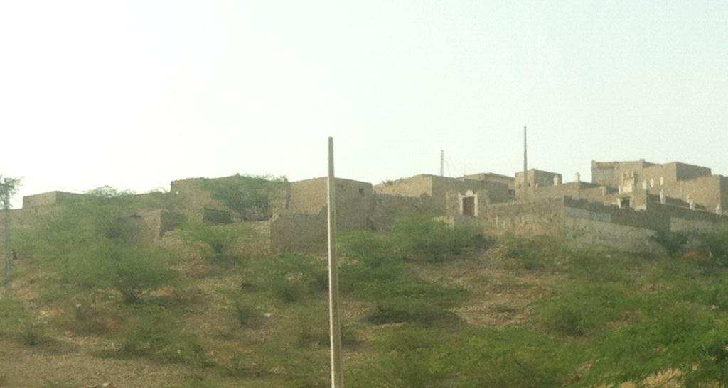 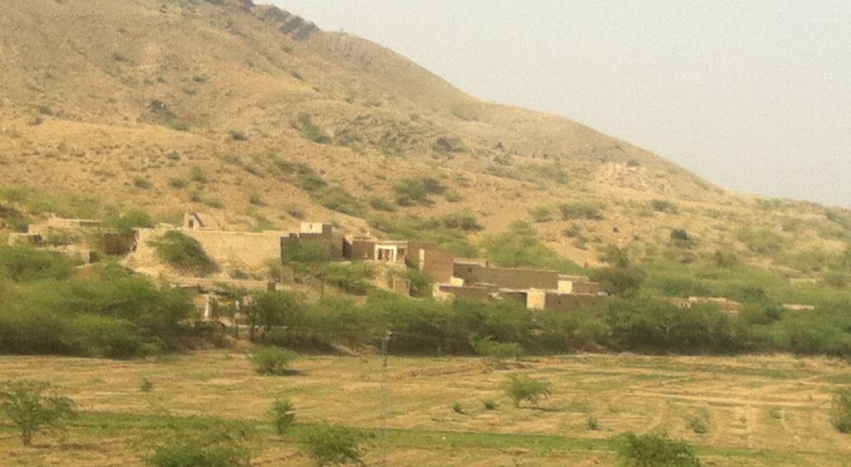

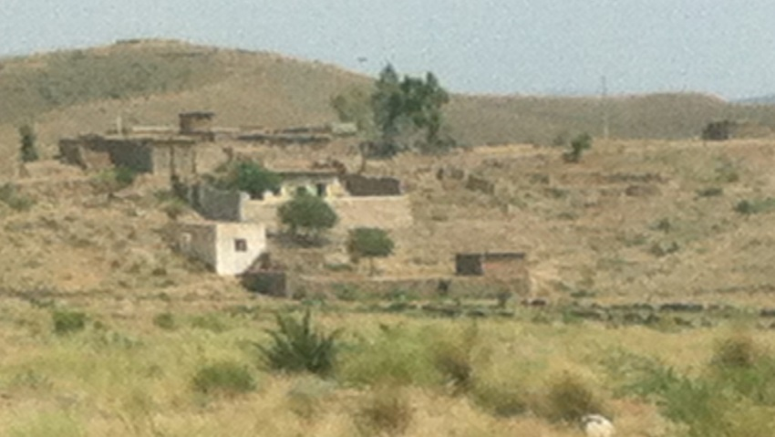 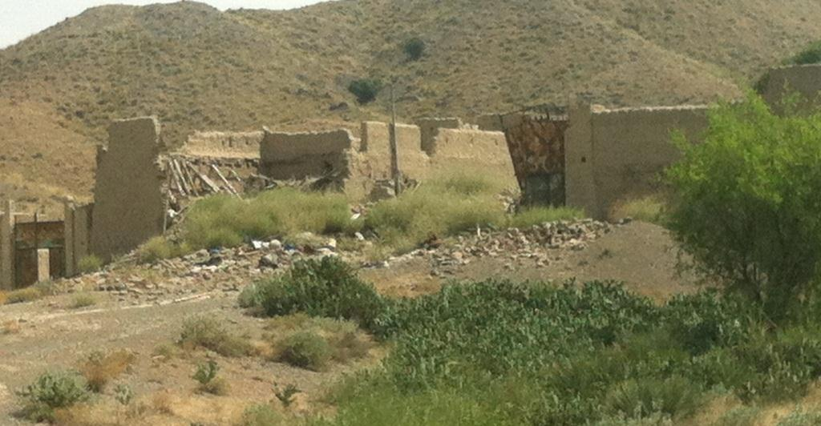

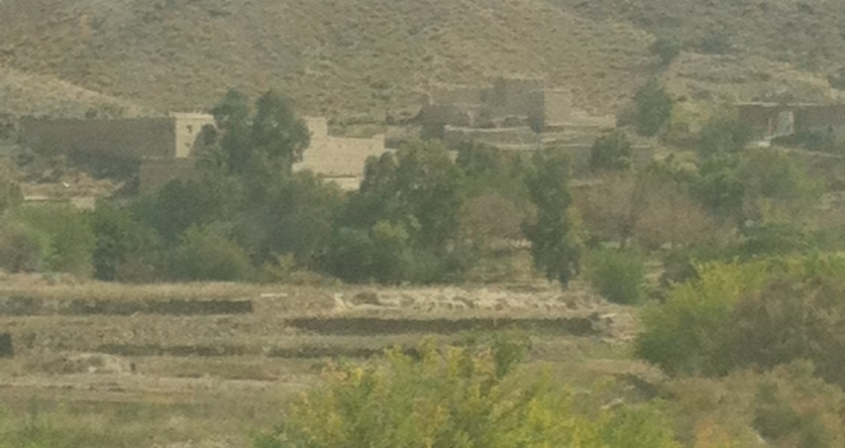 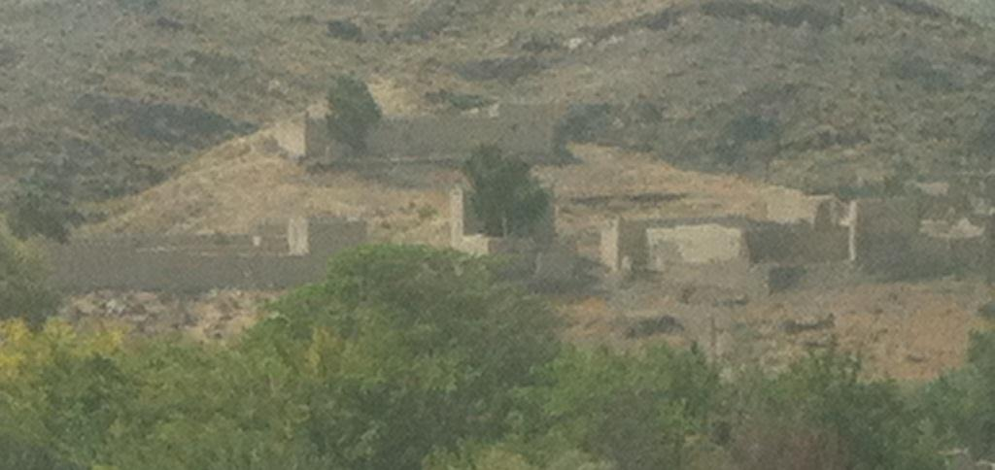

Compiled by Faraz Ahmad & Imran ullah Jan