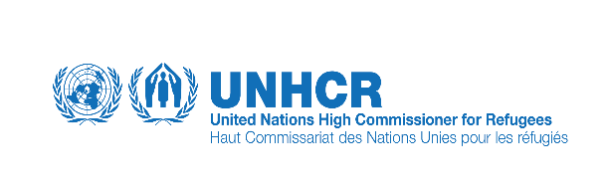
Monitoring visit to South Waziristan
From: 02-06 May 2016
Brief Background of S. W Agency & Map:
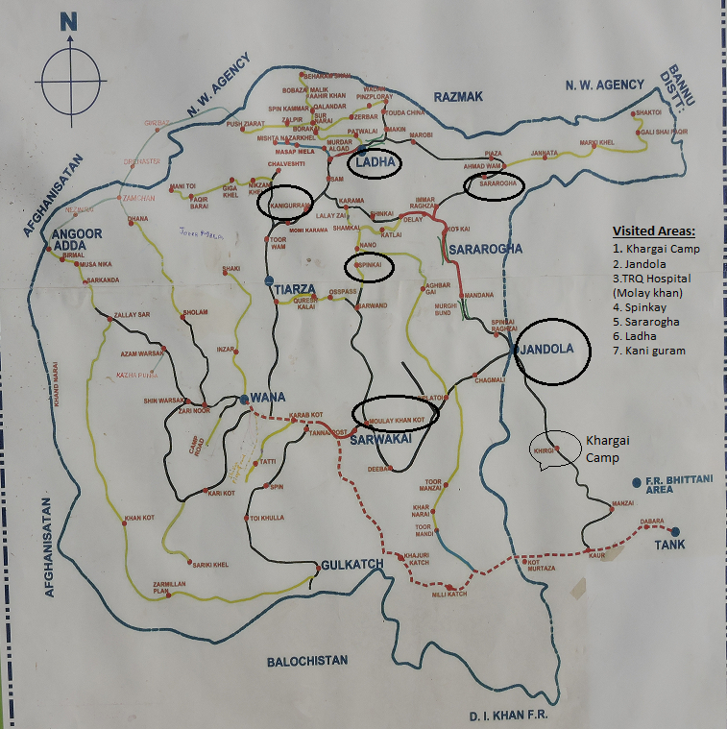

South Waziristan Agency:
S.W agency is a mountainous region of North-Western Pakistan, bordering Afghanistan and covering an area of 6,620 square kilometres, with a total estimated population of 430,000. Waziristan is divided into two agencies for administrative purposes (South and North). It comprises the area west and south west of Peshawar between the Touchi River to the north and the Gomal River to the south. South Waziristan is the largest agency of FATA. It has two headquarters, Tank in winter and Wana in summer.
South Waziristan Agency is administratively divided in three Sub-divisions, Ladha, Sarwakai and Wana and nine tehsils i.e. Saraogha, Sarwakai, Teyarza, Ladha, Wana, Barmal, Shawal, Makin and Torkholaa. The agency is the homeland of the Masoud, Wazir, Barki and Sulaman Khel tribes.
Two sub-divisions of South Waziristan Agency (Sarwakai & Ladha) were notified as conflict areas and the military operation started against the militants in 2008. Both the conflict sub-divisions are inhabited by Mehsud tribe and thousands of families were displaced. As per UNHCR IDP factsheet, presently some 62,000 families were displaced with majority of them finding temporary accommodation in DI Khan and Tank. Total Registered IDPs from SWA (NADRA Verified) are 73,405 Families
The first phase of return to South Waziristan IDP’s started in December 2010 and continued in different phases to the clear areas under the guidance of Return Task Force and agreed return framework. The humanitarian community has played an important role in provision of assistance in terms of registration, food, shelter/NFIs, WASH, health, nutrition and livelihood support to the IDP’s during the displacement and upon return.
Mission Members:
- Nasir Jalil
- Faraz Ahmad
- Gulam Samdani
Background & Purpose of Mission:
The Policy and Strategy meeting of October 26, 2010 requested the formation of a Returns Task Force (RTF) co-chaired by FDMA and UNHCR to develop a plan for Safe, voluntary and assisted return of FATA IDPs to their areas of origin.
The main purpose of the mission is to monitor the newly IDP’s return, Shelter relief activities and conduct post return monitoring both on embarkation points and in the villages.
Security situation
UNDSS conducted a security assessment of the area and noted that acceptable security arrangements were in place at returnees villages. The security situation in the areas was observed to be stable. The main roads were accessible and dominated by Law Enforcement Agencies with additional security check points on road and on surrounding peaks.
All the newly de-notified villages are sensitized and cleared for return. Level -3 clearances has been done, however, as per military SOPs bomb disposal units carry out sweeping of the tracks in routine.

Visit to Khargai Camp (03-May 2016):
The mission visited the Khargai camp and met with the relevant Military personal and monitors the process of IDP’s return. The protection and CCCM members interview the SRSP partners and ask for the quarries appear in the staging points. They have shared the database sheet with us which shows that 12,567 individuals have been planned return so far. They have also inquired about the unregistered families and their status.
Informal discussions were held with the returnees who expressed dissatisfaction on the Government rehabilitation assistance. There were families returning without VRF and any other cash assistance for their damage house compensation. They narrated that we have evacuated the area on short notice and our houses kept vacant from last 8 years and now we are being pushed to return. They seems extremely depressed and hope less for the government strategy as their houses are damaged and how they will survive upon return.
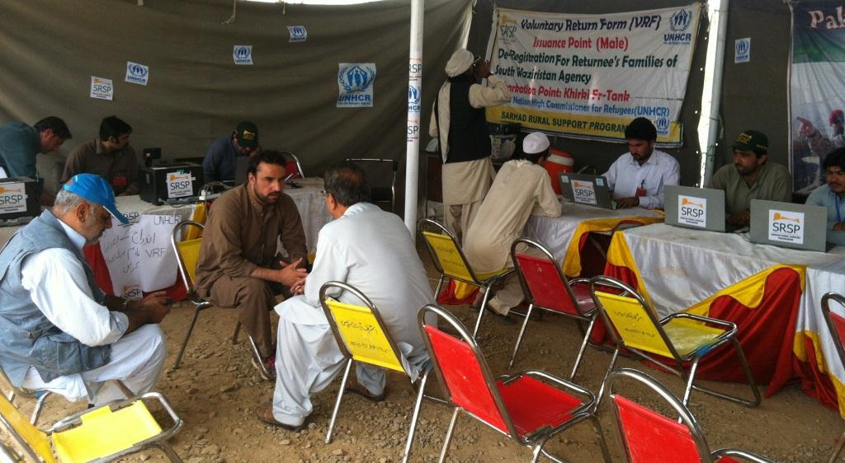
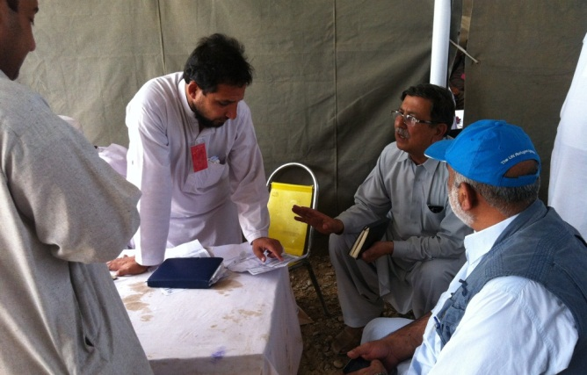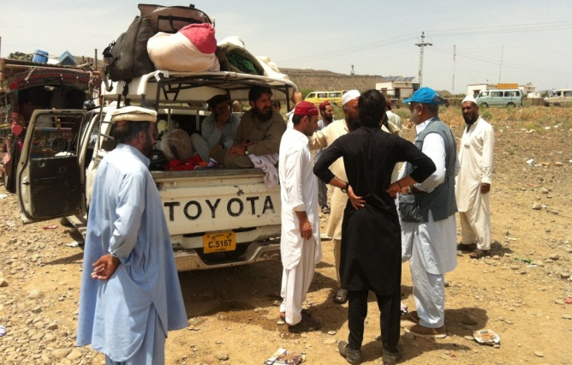
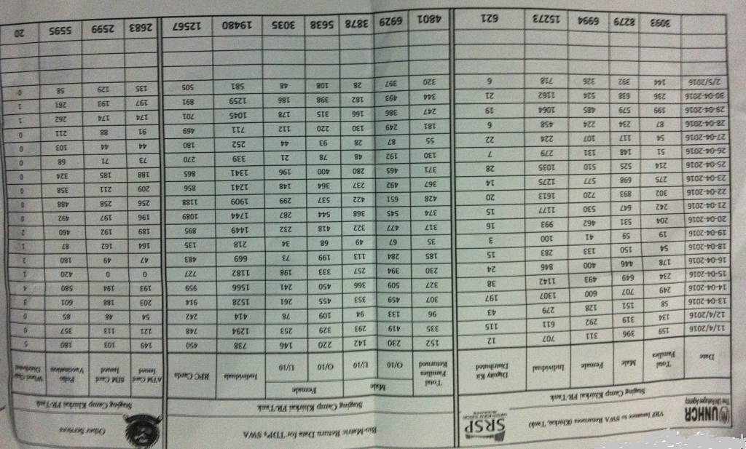
Visit to TRQ hospital (Mulay khan):
The TRQ Hospital is 76 km from Tank. The mission visited newly constructed 40 beds category D hospital, with specialized units MCH, Gynaecology, Medical, Surgical and pediatrics. The staff are working including DHO, Female Doctors, LHV’s and other paramedical staff. The FRD staff has briefed about the hospital.
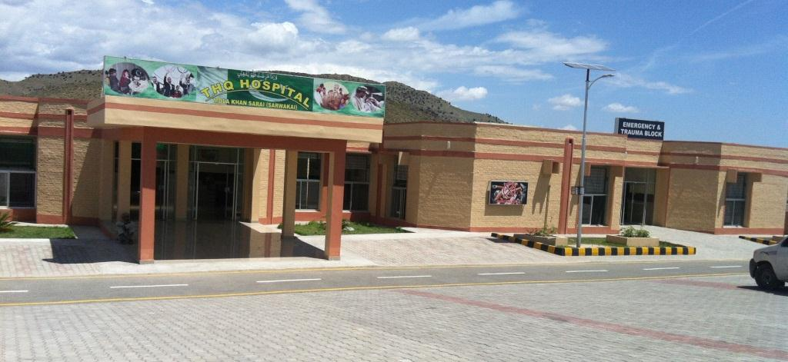
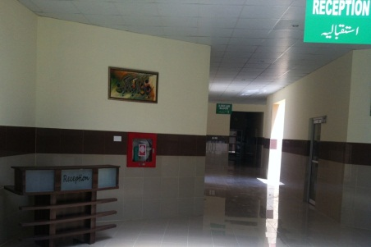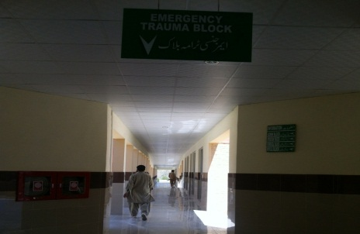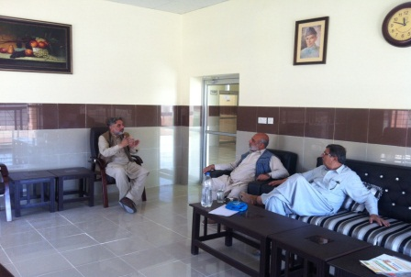
Visit to Post return area of Tehsil Tiarza village Spinkay:
Our team visited the area for the monitoring of post return in Tiarza. The village is approx. 95 km from Tank. The spontaneous returned of IDP’s occurred in this area. The damage in this this area is too much and the UNHCR in collaboration with Implementing partner SRSP distributed the Tents in the area. We physically verify the Shelter and its need.
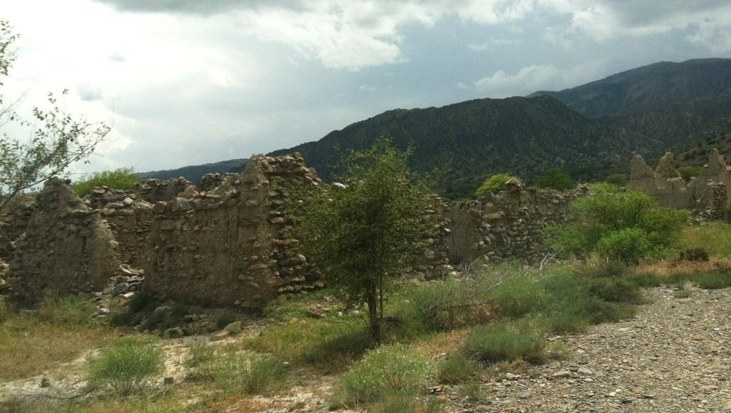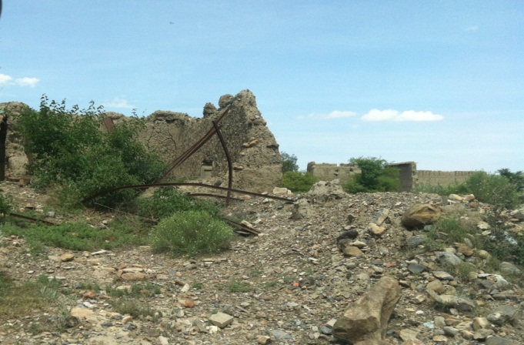
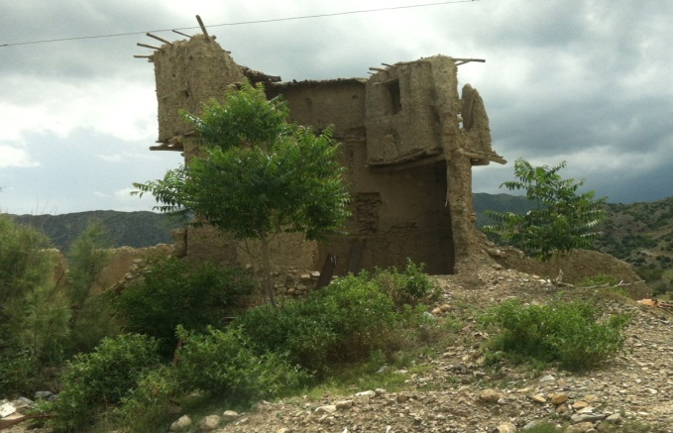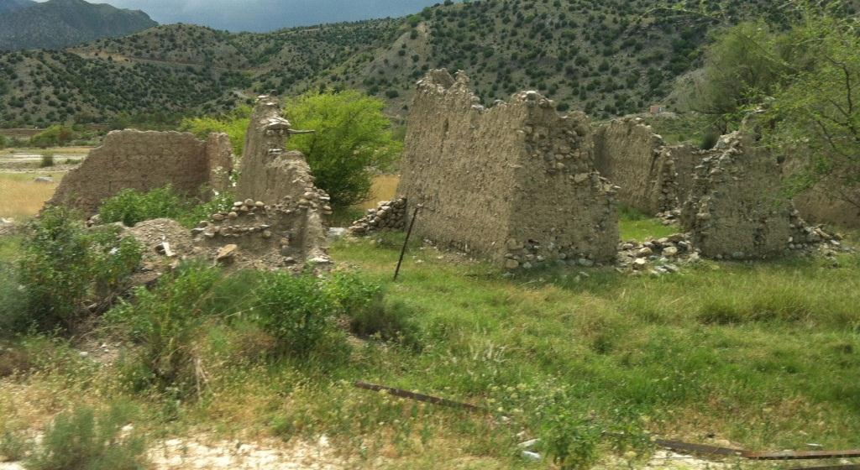
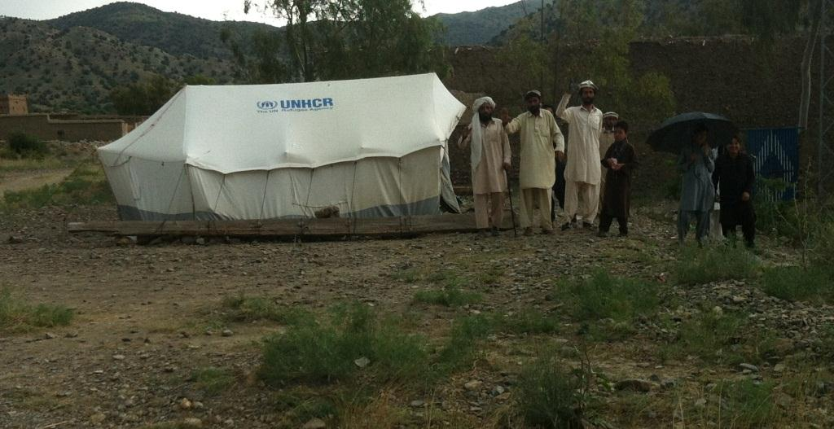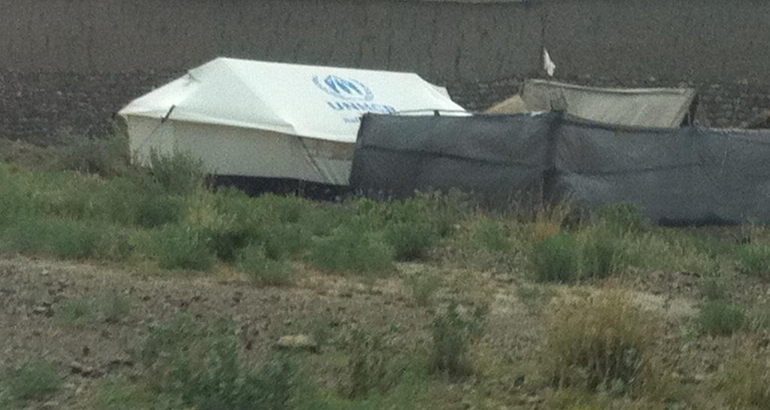
Visit to Lada & kani guram:
The Ladda is situated on North of the agency and it is 120 km away from Tank. In lada the spontaneous returned occurred and 70% houses damaged and the houses which seems physically intact, the roofing is badly damaged and almost vanished due to weather condition and they are not in live able condition.
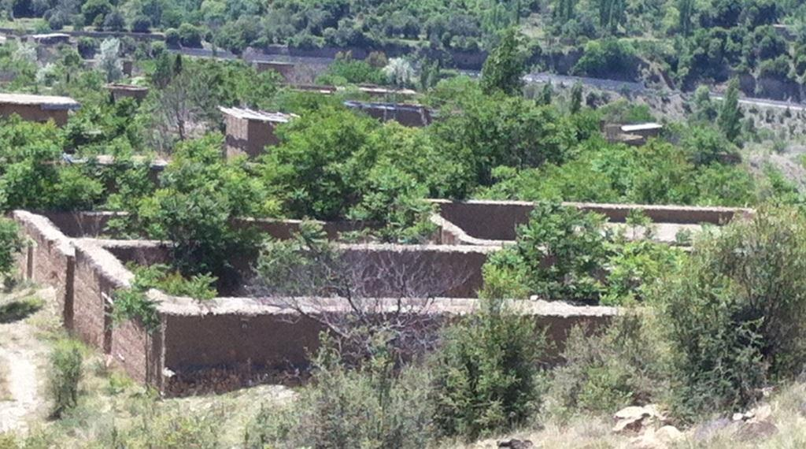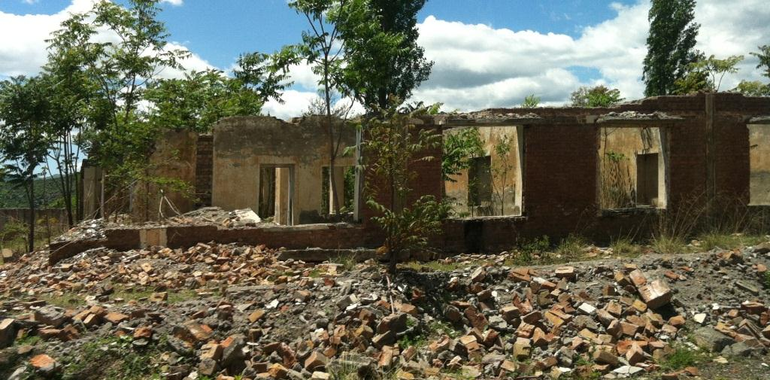

In Kani guram village 100 % damage found. Recently the return process started and the few members of the family return as there is no living space for them. The houses are constructed in steps and the damage is high. The picture of both external and internal damage shows that houses are unable to live. There is dire need of shelter in this area.
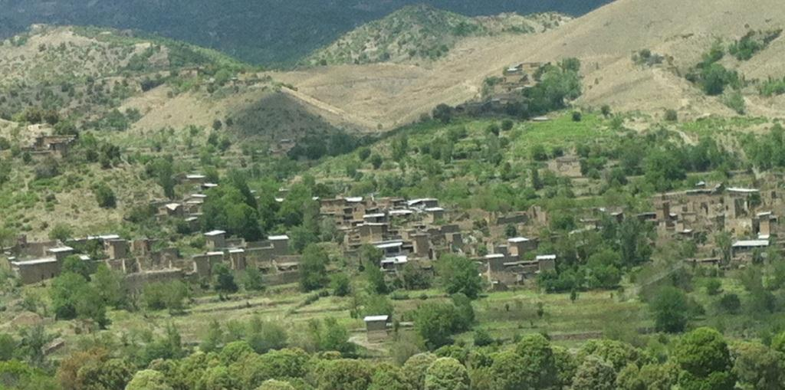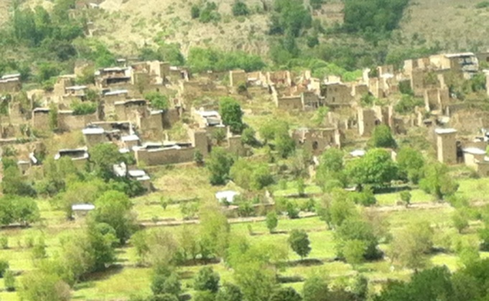
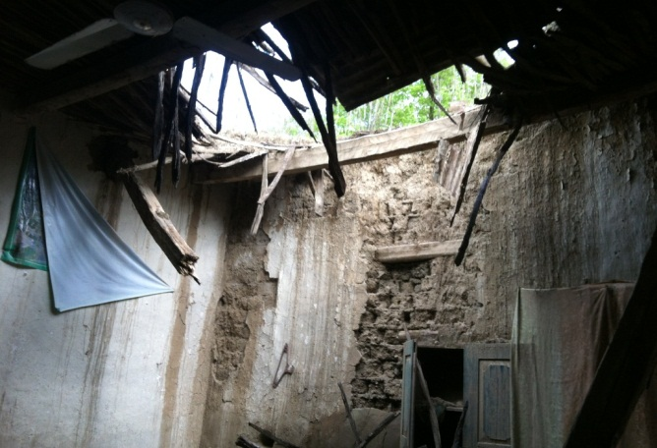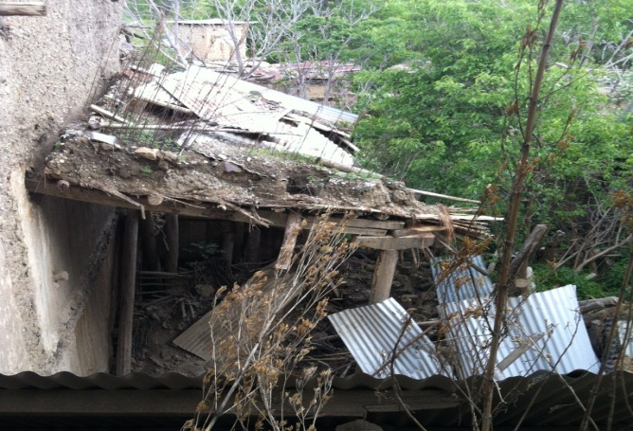
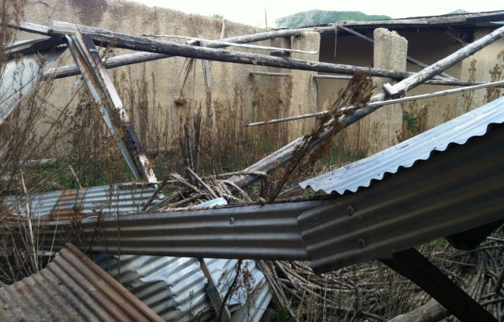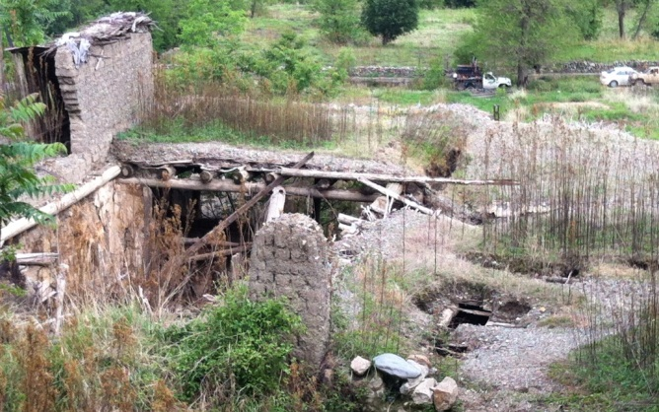
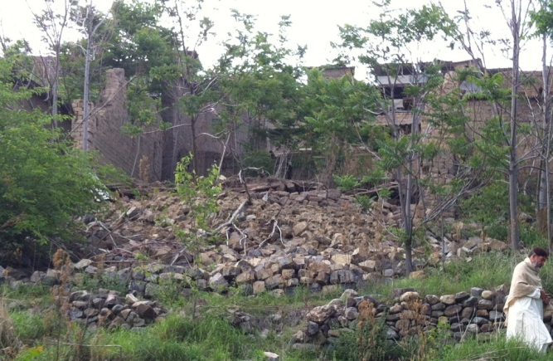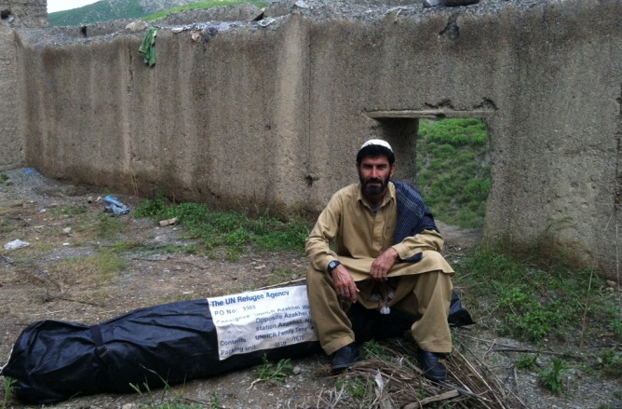

Recommendation:
- As the magnitude of damages in the area are high, mainly due to weather rain and snow as the population had left the area 8 years ago. Almost a blanket shelter assistance following by prompt transitional shelter will be required.
- The houses in this area are 2-3 stories and are built in steps, it is very difficult for them to reconstruct the houses at this stage and rebuilt it in short duration after return. 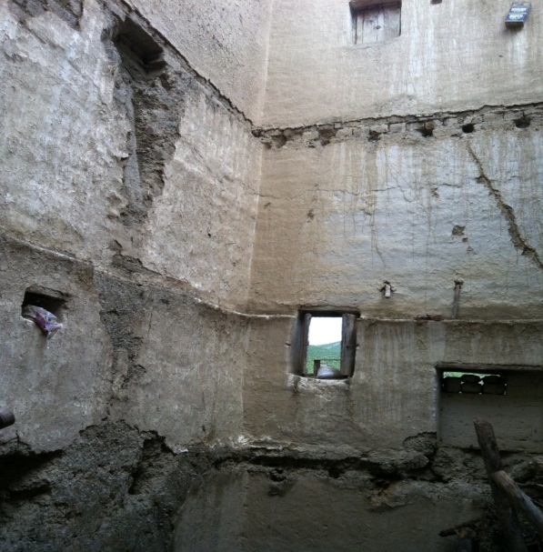 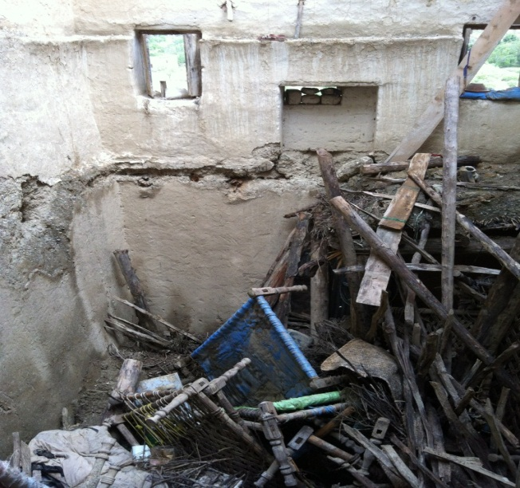
- The level of damages are very high, estimated around 70 - 80% which will required fund raising to reach out the people in need of shelter assistance upon return (emergency & transitional shelter). Donor missions are highly recommended to assess and respond the basic need of the returnees.
- House damage survey of FATA secretariat/RRU unit should be expedited to compensate the damage of returnees.
- Plastic Sheet/CGI sheet should be provided to all the beneficiaries as the immediate need.
- Vulnerable returnees without VRF but in the possession of return facilitation Card should also be assisted based on the criteria.

